Letterforms As a Barometer for Social Mood, Cultural Shifts, and Collective Memory

Sophia Hornyak

Mellon Research Fellowship 2026
Brightpoint Community College & Virginia Commonwealth University
April 10, 2026

At what point do we tire of the discourse surrounding attention economy, the attachment to our devices, the detachment to the world around us, and the isolation it creates? Time is relented through our total consumption of making ends meet, progressing our careers, fielding opinions, and indulging in the commodification of self-care. Is the exhaustion a byproduct of the guilt accompanied by the inability to snap out of the technological hypnosis we’re in? Or is it that we are exhausted from a world designed to shorten our attention span in the hopes that we do not look up and recognize that we are caught in a web constructed by power structures?
Our neurocognitive architecture was constructed for a sensory environment radically different from the one we live in now; evolution does not move at the pace of technology. If it weren’t for compartmentalization, many of us would only be a post away from an existential crisis. The pressure and pace of our western, capitalistic society feel like a far departure from our naturally intended rhythm. The tightening of space and quickness of time that advancement brings us feels as though they are in exchange for our agency and autonomy. Overstimulation seems to be the word of a lifetime, leisure correlates to the accumulated time at work, and politics is a live dramedy where the power elite make decisions for us, to us, and often, unknowingly, by us. The sea of information is riddled with predators hiding in plain sight. We all know it. But how do we decipher it?
Language gives sound to our thoughts, but the written word materializes them. Our society is filled with words more than ever: social media, signage, branding, and emails dominate our visual landscape, and our actions are organized around them: we try to find the right ones, we write them, read them, confuse them, mispronounce them, and erase them. It’s clear that in a world filled with billions of people, there would be so many thoughts to jot down, but what else could be said beyond the words they represent? Are letters not just vessels to transition the intangible to the conveyed? Don’t meanings dissolve with time? Doesn’t sentence structure shift with culture? What else can a word do besides freeze discourse in time?
In the tradition of great philosophers of the past, I thought about thinking. If the written word materializes through language, language, then, exists by thought, but how does an original thought not lose pieces of itself on the long journey of translation? During my research, I visited The Kislak Center for Special Collections, Rare Books, and Manuscripts at The University of Pennsylvania. One of the manuscripts I chose was based on the script style it contained. As the curator, Dr. John Pollock, placed the oldest book in their collection in front of me, he asked if I wouldn’t, perhaps, be interested in its contents. What was laid gently on two triangular foam blocks was a copy of Aristotle’s Peri Hermeneias (On Interpretation) dated approximately at 850 AD.
If you’re by chance not familiar, the little-known author asserts that spoken words are symbols of affections of the soul, and written marks are symbols of spoken words. The affections of the soul, which spoken words directly symbolize, are the same for all human beings, as are the things of which those affections are likenesses. But spoken sounds and written marks differ from person to person and culture to culture. Aristotle then proposes a four-level hierarchy of representation: First, there are things in the world. Second, there are affections of the soul, meaning mental impressions or thoughts, which are likenesses of those things. Third, there is spoken language, which symbolizes those affections. Fourth, there is writing, which symbolizes spoken language. Each step is one degree further removed from the original thing.
This concept sounded familiar, and in my resonance, rummaged through my bookshelf for the philosopher whose interests in power structures encourage my own. In The Order of Things, Michel Foucault says:
Representations are not rooted in a world that gives them meaning; they open of themselves on to a space that is their own, whose internal network gives rise to meaning. And language exists in the gap that representation creates for itself. Words do not, then, form a thin film that duplicates thought on the outside; they recall thought, they indicate it, but inwards first of all, among all those representations that represent other representations.
In sitting with the words of the wise, I found myself asking: If a written word is a representation of a representation, wouldn’t it need supplementation to convey the intention of the original concept?
Type, font, style, space, and color are designed to grab our attention and appeal to our preferred aesthetic, but before graphic design, what did the form of a letter do? Could one read into the collective emotional state by a flyer created by letterpress? Before punctuation, italicization, even before space separated words, could the form of a written letter tell us more about the scribe assigned to the codex, or the world in which he lived in? Is the form of a letter more than the scaffolding that holds up a complete word to convey a thought? If styles and artistic qualities move with the moods and shifts in culture, wouldn’t letterforms do the same?
Though commenting on the individual character, a quote from American Transcendentalist, Ralph Waldo Emerson comes to mind as applicable to the collective,
The life of man is a self-evolving circle, which, from a ring imperceptibly small, rushes on all sides outwards to new and larger circles, and that without end.
As a whole, we are indoctrinated with the idea that advancement comes with the progression of time, but time is not linear. If we look to history not as a form of nostalgia, but as collective lived experience, we can see that we return to structurally similar conditions, albeit never identical. Experience gives us the ability to recognize patterns, make informed decisions, and offers a reminder that whatever it is we are experiencing, we have been through something similar before. Just as a child calls to a parent during times of stress, the collective can call to its history.
- Letterforms as a Deliberative Body
If you want to know what a society is feeling, not what it declares or what institutions publish, but what the collective experiences, look at what it makes. The creative seat of a human being is where inventiveness and emotion collide. Regardless of any commodification of the element, idea, or item made, the creation itself comes from the same internal space from which our thoughts arise.
The past gives us grammar for rendering the present. But when it is supplemented by cross-disciplinary critical theory and praxis to the recovered pieces of the past, it may give us a new lens of understanding our social ecosystem. Letterforms are instruments, witnesses, and residue of power. They are not simply neutral shapes marching toward perfection.
If thoughts are private, and the spoken word disappears, it is the written word that persists. It is in the word’s form, not its spelling, that signifies the conditions and mediations of its production. Over time, letterforms are responsive, socially negotiated, culturally synthesized, and historically situated. Stylistics of lettering from handwritten to digitally constructed, evolve through social and cultural evolution. The tension is not in development itself; it lives in the pull between institutional power, which grips at one end, and the social collective's response, which holds at the other. This makes them the survivors of many competing possibilities, not simply the natural product of time. By this understanding, letterforms cannot simply be passive vessels of communication; they are active visual cultural artifacts that register social tension, ideological shift, and collective psychological experience. They are social barometers embedded in the complex fabric of collective life.
In the re-evaluation of lettering aesthetics as cultural and emotional measurement, it is pertinent to collapse the divide between design theory and art history. By the removal of disciplinary construct, a space is created to allow the complexity of meaning to be present, as translations, representations and language, are always shifting as they are fluid, unstable, and contextual. As such, so are the forms in which their letters take.
- Framing The Inquiry
This project proceeds from the premise that letterforms have been fragmented across fields precisely because they exceed any single one; reading them whole requires moving across paleography, art history, design studies, and cultural theory simultaneously, dissolving those boundaries to construct a lens. This is not a scope of simple determinism: the styles of letterforms do not cause social change nor vice versa, but rather, that letterforms are co-constitutive. This project reads the present through the past, treating historical comparison as an analytical method. Past situations, as cultural psychologists Brady Wagoner and Lisa Herbig observe, are closed while their interpretation remains open, presenting a limited range of possible scenarios rather than a determined outcome. The careful analysis of one illuminates the other. The conclusion, of which, is non-teleological, serving as a source of pattern recognition and historical legibility to assist in the present orientation. This project requires a methodology as interconnected as its subject matter. Recognizing that critical theory, design theory, art history, and social constructs of power are connected, interdependent, and intertwined, an interdisciplinary praxis grants a better sense of the whole.
The focus is on arbitrary systems of domination, how they disperse from a centralized place of power, and who and what slows them down. The tension between power and its resistance does not resolve in inevitability; they accumulate. Each leaves a residue in the forms that follow, and embed themselves into society at their own pace, respectively. If art, design, institutions, class, capitalism, and cultural power all shape visual form, then visual form becomes evidence. Letterforms are uniquely powerful as such, because they saturate daily life and are not occasional cultural objects, making them extraordinarily sensitive indicators of social change. If architecture preserves space and fashion marks moments, then letterforms preserve knowledge across time.
- The Methodology: Tracing The Form
This paper proceeds in four movements. It begins by establishing a theoretical framework for reading the model established above, drawing on Saussure, Bourdieu, Foucault, and Latour, Williams, and Hegel to construct a non-teleological model of formal evolution. It is one in which letterforms are responsive, socially negotiated, culturally synthesized, and historically situated. From that foundation, it traces a genealogy of three pivotal moments in Western letterform history: Carolingian Minuscule, Humanist Script, and Times New Roman. This case study in the pattern this model describes is grounded in firsthand archival research, drawing on direct engagement with primary materials at The Kislak Center for Special Collections, Rare Books and Manuscripts at The University of Pennsylvania in Philadelphia, as well as, as well as secondary scholarship. It then turns to the central comparative argument: that the First and Second Gilded Ages share a structural socioeconomic topology that produces legible and analogous responses through letterforms used, readable through direct material engagement at The Rare Book and Archival Collections at the library of the Virginia Museum of Fine Arts, and by also conducting original field research in the form of interviews with practicing professionals whose work centers on letterforms.
The research concludes by arguing that the patterns brought forth in this research, through the theoretical framework, are far from being deterministic, and reveals a constitutional balance of power in which residual and emergent forms persistently negotiate against dominant institutional vocabularies. What this project ultimately proposes is an epistemic reorientation: that the aesthetics of letterform, long treated as the background noise of history, are in fact among its most intimate records.
- Minding The Gap: A Non-Teleological Model of Formal Change
There is a gap in the existing theoretical landscape as it pertains to letterforms; no comprehensive body of work has yet treated letterform as a primary site of cultural and material meaning in the way this project requires. Design theory offers rigorous tools for understanding how form functions, but it tends to stop at the threshold of production. Its most generative thinkers, such as renowned graphic designer Ellen Lupton and visual theorist Johanna Drucker, illuminate the mechanics and epistemology of visual form with precision, but the conversation ultimately returns to the design studio, or retires at the level of the system. Art history and sociology offer the interpretive and contextual frameworks, but they have largely left letterform to the designers, treating them as background rather than evidence. Paleography comes closest to the material: reading the form directly, dating the hand, tracing regional influence and scribal practice across centuries, but it tends to stop at identification. The why, what social pressure produced this shift, what the form was negotiating, what it carried forward and what it shed, those questions sit outside its traditional scope, filed somewhere between the two disciplines, claimed fully by neither.
In Visual Thinking, pioneering psychologist and art theorist, Rudolf Arnheim writes:
The visual medium is so enormously superior because it offers structural equivalents to all characteristics of objects, events, relations. The variety of available visual shapes is as great as that of possible speech sounds, but what matters is that they can be organized according to readily definable patterns, of which the geometrical shapes are the most tangible illustration. The principal virtue of the visual medium is that of representing shapes in two-dimensional and three-dimensional space, as compared with the one-dimensional sequence of verbal language. This polydimensional space not only yields good thought models of physical objects or events, it also represents isomorphically the dimensions needed for theoretical reasoning.
To understand the complexity of the aesthetics of language made material, this work weaves through various theoretical frameworks and disciplines to grasp the collective memory embedded within them. Note, this is not a critique of any of these traditions, nor is it a composition of a who's who of philosophy. It is another avenue to access what art history has always sought to do: to interpret the meaning of visual objects in relation to their historical context, to trace how that meaning shifts across time, and to read the objects as social, political, and culturally legible, through their form.
The lens required to do that work is post-structuralist in its orientation. This philosophical movement asks not just what a structure is, but who constructed it, whose interests it serves, and where its authority is arbitrary rather than inherent. Applied to letterform, the question becomes: where did this form get its authority, who decided that, and at what point did that decision become invisible enough to stop being a decision at all?
What follows is an attempt to construct a composite lens. The gaps between frameworks are as analytically useful as the frameworks themselves; they offer space for interpretation beyond construct and disciplinary divide. Each framework that follows opens a door, assisting in what our cognition is built to do: find a pattern. This project seeks to move beyond the capitalistic value of production. It also attempts an embodied epistemology by anchoring in the forms of letters from the manuscript page, the painted sign, the institutional typeface, to the aesthetics of words on branding and on our screens, as the body language that assists in the articulation of the word.
By creating a framework that treats letterforms as condensed archives of collective meaning, and by moving away from formalist or purely aesthetic criteria, there is an opportunity to fade the tension of construct. Through an interdisciplinary, multi-perspectival approach, there is a function of decolonial orientation. Decoloniality is different from decolonization. Its critical orientation asks the foundational question of what forms of knowledge, being, and power were installed by colonialism at the deeper architecture of how the world is organized.
By refusing to anchor in any single discipline's evaluative criteria, and by bringing design history, critical theory, archival material, practitioner interviews, and hands-on visual analysis into conversation with one another, different truth-claims are held in productive friction. This keeps the inquiry alive. It is worth noting the self-awareness that this work uses a largely European canon of critical tools, precluding it as purely decolonial. One cannot simply opt out of structures that are deeply embedded, but that is precisely why this work is non-teleological. Letterforms do not develop in a straight line toward perfection or resolution; it accumulates, resurfaces, gets suppressed, and persists in forms that carry the residue of what came before them. A linear argument with a singular conclusion would misrepresent the very thing it is trying to describe. The structure of this inquiry is shaped by the structure of its evidence. To follow the form honestly is to follow it without predetermining where it ends.
- The Theoretical Framework
To follow a comprehensive train of thought, it is important to start with linguistics. Ferdinand de Saussure (1857-1913) a Swiss linguist widely credited with being the founder of modern linguistics. His Course in General Linguistics (1916) was posthumously published by his students from lecture notes, housing his core contribution: the theory of the linguistic sign. The doctrine argues that the linguistic sign has two inseparable parts: the signifier, the sound or written mark, and the signified, the concept or meaning it produces. A mark on a page corresponds to a sound of the spoken word, which corresponds to a thought in the mind, which relates to a thing in the world. The written symbol is arbitrary; there is nothing inherently tree-like about the letters t-r-e-e. The connection is purely conventional and entirely dependent on shared agreement to function at all.
To take this further, if the relationship between mark and meaning is arbitrary, then the visual form of that mark, the specific shape of the letters, is also as such. And if this is true, then whoever decides which forms carry authority, legibility, and legitimacy is making a power decision, not a natural or inevitable one. It is the form of a word, not its spelling, that signifies the conditions and mediations of its production.
This framing opens the door to French sociologist Pierre Bourdieu (1930-2002) whose work on cultural reproduction remains foundational across the humanities and social sciences and explains why that arbitrariness becomes invisible. In Distinction: A Social Critique of the Judgement of Taste (1979) he argues that taste is not a matter of personal preference, but a system of social distinctions rooted in cultural capital and habitus. Habitus, as Bourdieu coined the term, is the internalized set of dispositions, ways of seeing, judging, and moving through the world that individuals acquire through their social position and education without conscious awareness.
By Bourdieu’s reasoning, the arbitrary becomes stable through socialization. From childhood, through education, through institutional exposure, through every book, certificate, and publication encountered, you absorb which forms carry weight and which don’t. This invisible rule is dispersed through taste, as instinct, as what simply looks “right” or “wrong.” That is habitus: a disposition so deeply internalized it feels natural rather than learned. This is how millions of people can agree that a typeface means authority, or a script means legitimacy, without ever discussing it. This is how the arbitrary achieves its remarkable reliability between minds; the arbitrary nature fades and the convention become invisible. Once it’s invisible, it stops being questioned. Once it stops being questioned, it then becomes power.
The dynamics and meaning of power in this context are best taken from the work of the earlier mentioned French philosopher and historian Michel Foucault (1926-1984). Foucault’s thinking across Discipline and Punish (1975) and The Order of Things (1966) fundamentally reframes what power is and how it operates. Power, for Foucault, has no single source and requires no coercion. He coined the term biopower to describe the way authority is continuously reproduced through the interaction between institutions and people, through the bodies and habits of those who absorb it without awareness, mediated and in flux, never static, never settled. To describe its architecture, Foucault develops the concept of the dispositif, or apparatus: the network of institutions, discourses, laws, and material arrangements through which power circulates without explicit decree.
Applying these Foucauldian concepts to letterform helps explain why certain scripts carry institutional weight while others are rendered marginal, illegible, or decorative. The quality of the forms themselves is not the reason for the distinction, but the system in which they operate. What Foucault describes structurally as power, French sociologist Bruno Latour (1947-2022) traces its dissemination. Through his development of actor-network theory, Latour shows how a decision, a standard, or a form, travels through a network of actors, each enrolling the next, each borrowing legitimacy from the one above it in a discernible hierarchy.
By pairing these systems, we arrive at precisely why typographic legitimacy requires no force to become engrained. The decision spreads through a chain of adoption in which each institution borrows credibility from the last: from a publisher to a newspaper, from the newspaper, a bureaucratic office, from the bureaucratic office into the school systems. This is how letterforms become standardized. By the Foucault/Latour logic, the apparatus functions most completely when its construction is unthinkable, when the suggestion that a font carries power feels absurd. The skepticism itself demonstrates exactly the depth of normalization the Foucault-Latour thread-line draws. By the time the form reaches the classroom, no one is asking why, and as Bourdieu illustrated, at this point, no one is even thinking to ask the question.
To understand the cultural implications that letterforms have, it must be understood that power weaves its threads through the cultural fabric of its society. The model of residual, dominant, and emergent cultural formations was developed by cultural theorist Raymond Williams (1921-1988). The dominant describes what institutions actively amplify, normalize, and reproduce as the standard. For example, in typography, Helvetica and its neutrality as the default voice of corporate and institutional communication. The residual describes what has been superseded but persists, carrying the social relations of an earlier formation. This would include the contemporary hand-painted sign, the blackletter tattoo, and the craft letterpress as active memory carrying the resistance in the production of form itself. Lastly, the emergent describes what is being negotiated at the edges, new forms and practices that haven’t yet been absorbed or suppressed by the dominant. Critically, this model was not developed with aesthetic categories in mind, instead, it offers descriptions of living social relations carried in practice. This diagnostic system fits naturally within the Foucault-Latour architecture, naming the cultural formations through which power disseminates and the practices through which it is absorbed or resisted.
A digital recreation of a historical letterform borrows the visual surface of a past practice; the strokes, the weight, the historical associations, but without the embodied knowledge that produced them. The form is present, but the practice is absent making the digital recreation dominant. A contemporary artist whose hand still paints signs carries something categorically different: the knowledge lives in the body. The craftsperson understands how paint behaves at scale, how letterforms must be optically adjusted to read correctly from a distance, how pressure and speed produce weight and contrast, all of that is present in the act of making the hand-painted sign residual. The form and the conditions of its production are inseparable. Emergence is best explained as the difference of what each sign signals. A hand-painted sign at a store would communicate “hand-crafted” or “artisan” while a digitally constructed hand-painted style sign would signal “hand-crafted style.” One signals authenticity, craft, and resistance to corporate sterility, the other is its simulation, metabolized and commodified as a $29 font family package on Creative Market.
The absorption of the aesthetic by the dominant renders the social relations that made it resistant or meaningful in its original context, neutral. The distinction between these three formations, and particularly the difference between the dominant and the residual as embodied practice, will prove central to the analysis of contemporary craft practitioners later in this paper. The question is not which mode of making is more authentic or more valuable, but what each mode of making reveals about the system in which it operates and the degree to which cultural agency remains possible within it.
If the Foucault-Latour thread-line explains how typographic authority spreads and normalizes, and Williams names the cultural formations through which it operates, French philosopher Jacques Derrida (1930-2004) and French literary theorist Roland Barthes (1915-1980) together address what happens to meaning inside those formations over time. Both thinkers, working within the post-structuralist tradition, argue that meaning is never fixed, never fully present, and never the exclusive property of whoever made the thing.
Derrida, focused predominantly on written word and language, is best known for having developed deconstruction as a method within the discipline of philosophy. Deconstruction applied to letterform means asking: what assumptions about legitimate form, readable script, and hegemonic typography are being held in place by oppositions that don't hold up under scrutiny? Legible versus illegible. Standard versus marginal. Institutional versus decorative. Derrida would say those oppositions are constructed, unstable, and maintained by power rather than by any natural property of the forms themselves.
Derrida’s concept of différance reshaped how language and meaning are understood, arguing that meaning is always deferred, always produced through its relationship to other signs rather than residing in any single one. A letterform does not hold meaning in isolation. It holds meaning by being in relation to every other letterform, every context in which it has appeared, and every association it has accumulated. Meaning is never stable; it shifts and is fluid. Applied to letterform, this means that no typographic decision, however institutionally enforced, can fully stabilize what a form carries. The residue of prior meanings always persists underneath the dominant reading, available to be reactivated.
Barthes extends this instability from the level of the sign to the level of the text and its maker. In "The Death of the Author" (1967), he argued that once a text enters the world, the intentions of its maker become irrelevant to its meaning. Meaning is not transmitted from author to reader; it is produced in the encounter between the reader and the text. Applied to letterform, this resonates directly with what this body of work seeks to convey: that letterforms operate as social barometers: the meaning of a script emerges through collective interaction with the form across time and is that its meaning is not fully determined by the scribe, the type designer, or the institution that standardized it. The blackletter tattoo does not mean what the medieval scribe intended, but means what every hand, every institution, every subculture, and every act of reading blackletter has made it mean. That accumulation is the archive this paper is reading.
- The Genealogy of Form: Three Moments, One Pattern
To ground this argument historically, I’ll recall Emerson from the introduction. If we understand that time is not linear, then Emerson inserts a non-teleological notion in saying that we move in circles, not progressing, just constantly moving. Though this paper is not about spiritual transcendentalism, it is about finding arbitrary systems of control. To illustrate how forms are embedded with the intention of the power constructs (Foucault) and how interpretation of forms come from collective engagement (Barthes) I offer a formulation analyzing three forms over three periods of time. In each moment, separated by centuries, the same gesture recurs: a period of fragmentation or institutional instability produces the conditions for a formal intervention. A decision is made from the central place of power, a letterform is standardized, the adaptation begins to travel, socialization of the arbitrary grants meaning, and the engagement of those systems then becomes collective memory.
The pattern that best demonstrates the system of form as an archive is the one that connects Carolingian Minuscule, Humanist Script, and Times New Roman. During the ninth century, the Frankish king, Charlemagne, achieved the most extensive unification of Western Europe since the Roman Empire. The Carolingian Empire was a pastiche of cultures, languages, and written words that needed one seamless form to ensure orders were clear over the vast landscapes, and that the kingdom asserted its authority as a unified state. Carolingian minuscule was developed as the chosen form to hold the message; inspired by an older form that reached far and wide, created clear avenues for delegation, and exuded its authority: Roman Script.
Four centuries later, Renaissance humanists were recovering from the fragmentation of medieval scholasticism. With the establishment of universities, the increase in business and administration, and the demand for scientific work, writing increased. The scriptoria ceased to be the central space for manuscript production, which led to bodies of work being written without the trained hand of a monk, codices were mistranslated, and scholars were subjugating information, making intellectual material hard to consume. Humanists, exhausted by the lack of clarity and legitimacy, craved standardization. In their search, they misidentified Carolingian minuscule as Roman and reframed it as Humanist script. The Humanist letterform made its way through the papacy, universities, and the emerging print industry, establishing it as the visual language of educated authority.
In 1929, Stanley Morison was tasked with coming up with a new typeface that helped the legibility of The Times of London and boost its readership without forfeiting wordcount. The years prior saw social and economic upheaval after World War I and the Roaring Twenties. The havoc of the times saw the rise of sensational reporting in the form of hard-to-read articles still largely formatted in the tradition of book typography, dense columns of small text, heavily serifed, with multiple typefaces competing for attention on the same page. The disorder of the newspaper reflected the disorder of a period moving towards the future, visually loud to sell papers in a newly loud physical world.
The post-war United Kingdom was in a different place socio-economically than it had been prior. Gone were the days of celebratory early-modern capitalism; the stock market crashing in 1929 had dramatic consequences on both sides of the Atlantic. Existing institutional structures, banks, governments, and newspapers were all facing a crisis of legitimacy and stability after the long incubation of distrust of elitism. Social reform movements were gaining traction globally: communism, fascism, feminism, adding pressure on the crumbling power structures. For The Times of London, a cleaner typeface was a survival decision. By creating a legible, authoritative letterform, they were creating a visual argument to assert their stability, credibility, and the stake in voice of record in a world that felt like it was falling apart.
Each period given in this formula followed a period of fragmentation and disorder. Central to any standardization or unification, is the importance of conveying a message of order
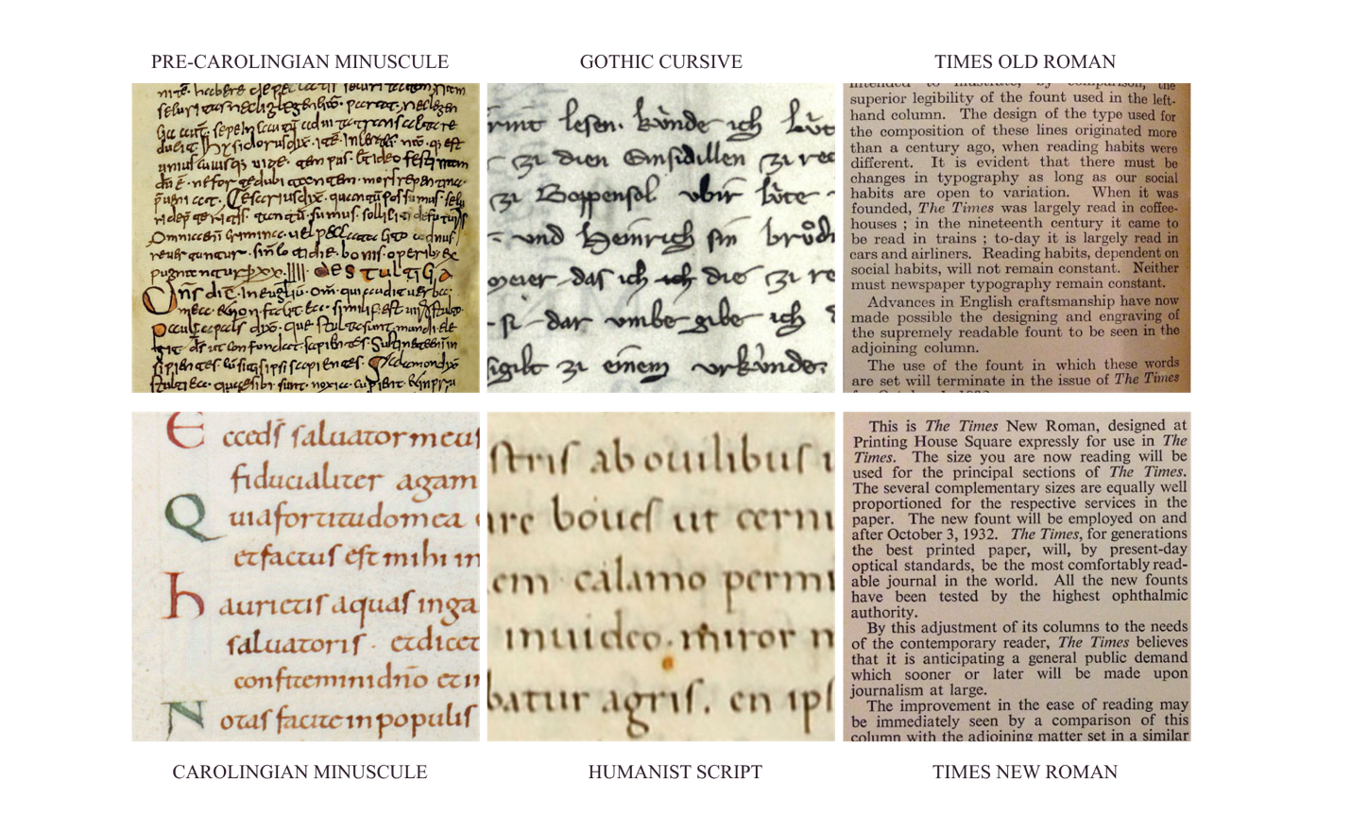
Figure 1. Top row, left to right: Pre-Carolingian Minuscule, Gothic Cursive, Times Old Roman. Bottom row, left to right: Carolingian Minuscule, Humanist Script, Times New Roman. Figure compiled by author.

while actively constructing it. During each period of reform, respectively, the form it created carried the visual memory of what inspired it, invoking the representation of the period from whence it came. Each reorganized, reframed, and re-authorized for a new historical moment. By having a springboard of power, each form traveled until it became integrated into each society. The visual continuity across the bottom row of Figure 1 is not coincidental; notice the clarity and order the row offers in comparison to its predecessor. That is the evidence of the residue moving through form, leaving its shape behind long after the intention that produced it has been forgotten.
The composite lens assembled in the preceding framework now comes into full view. Saussure established that the relationship between mark and meaning is arbitrary, held in place only by cultural agreement. Bourdieu explained how that arbitrariness becomes invisible through socialization, absorbed into taste, into what simply looks right, until the power decision embedded in the form stops feeling like a decision at all. Foucault and Latour showed how that invisibility spreads, through institutions borrowing legitimacy from one another in a discernible hierarchy, until normalization requires no force and no decree. Williams gave us the vocabulary for what persists: the dominant amplifying its standard, the residual carrying the memory of what was superseded, the emergent being negotiated at the edges before it too is absorbed or suppressed. Derrida and Barthes reminded us that meaning is never fully settled, that the form outlives every intention that produced it, and that its meaning belongs not to its maker but to every collective encounter across time. What the genealogy of Carolingian minuscule, Humanist script, and Times New Roman demonstrates is all of these mechanisms operating simultaneously, visibly.
This theoretical framework demanded primary source analysis. The chosen space was the exact one that inspired my interest in the intersection of philosophy and art history: The Kislak Center for Special Collections, Rare Books and Manuscripts at the University of Pennsylvania. The collection holds one of the few manuscripts written in Carolingian minuscule in North America. With the generous guidance of curator, Dr. John Pollock, I was offered interesting pieces within the collection that gave me a better sense of the transition of forms from one period to another. Moving from Carolingian exemplar, Dr. Pollock brought out the Diploma of Adam, Son of Teutio, commissioned by Otto III. I noticed immediately that the large piece produced in 1000 A.D., that the form of the letters began to change. The stylistics grew more ornate, with the capitals exhibiting early proto-gothic form. The spacing was significantly wider, the strokes multiplied, and despite its ornate ambitions, read less eloquently than the period before it. Unfamiliar with the history of the reign, I did a quick overview to learn that Otto III's contested legitimacy was a central issue to his rule. The instability of his court was easily read in the poor attempt of authority in the scribe’s ornate attempts, and its fracture in the additional, poorly measured spacing.
The most striking encounter was with a Psalter from Laon, France, dated to approximately 1058. Moving through its pages, I noticed inconsistencies that troubled me: the rotunda forms, typically associated with Italian, Spanish, and northern French scribal traditions, appeared irregularly, mixed into a hand that otherwise showed the compressed, angled characteristics of northern Carolingian practice. The confidence of the letterforms varied across the manuscript, suggesting either a single scribe whose hand shifted under some pressure, or two scribes of different formation working on the same document. The margins were generous, but the internal spacing was inconsistent, as if the organizing principle of the page was being negotiated because of instability of locale or disruption in the monastery.
As with the reign of Otto III, I had no historical context for Laon in 1058. I went to verify what I had seen and found exciting confirmation in the observation the form had already made. During the Carolingian period, Laon was the capital as well as the intellectual center of the kingdom. The capital’s scriptoria was the most significant one in northern France, but by the mid-eleventh century the region was under insurmountable political pressure. The following Capetian period was unstable; aggressive noble houses, including those of Anjou and Blois, were pressing on Burgundy, and the monastery at Laon had faced a revolt. The scribe, or scribes, who produced this Psalter were working inside that instability. The rotunda inconsistencies suggested influence from the south, the variations in confidence offered insight to either someone working under pressure, or one scribe picking up where another left off, and the negotiated spacing reflected instability; perhaps a lack of instruments for the dry-pointed margins or shift in location. The pressure of the socio-political landscape had entered the hand and left its mark on the page.
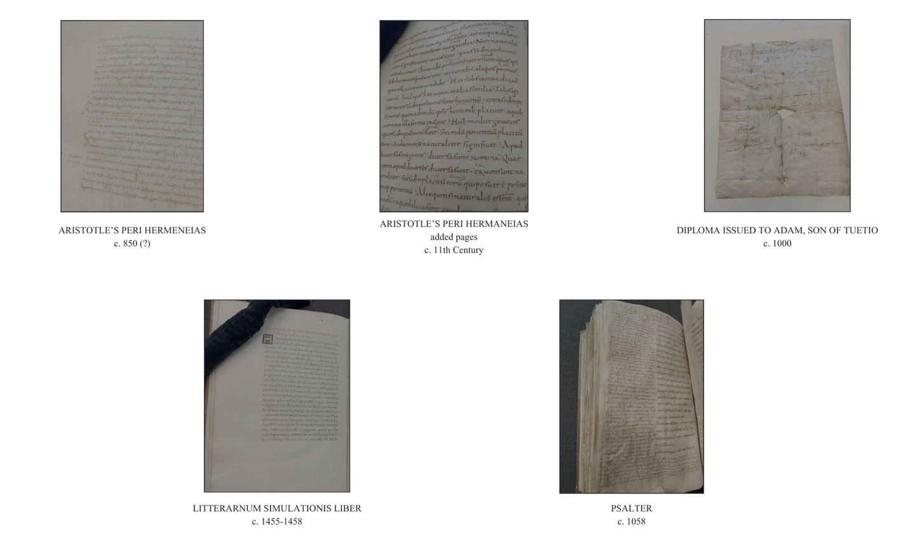
Figure 2: Primary source materials examined during archival research visit, Kislak Center for Special Collections, Rare Books and Manuscripts, University of Pennsylvania. Top row, left to right: Aristotle's Peri Hermeneias, c. 850; Aristotle's Peri Hermeneias, added pages, c. 11th century; Diploma Issued to Adam, Son of Tuetio, c. 1000. Bottom row, left to right: Litterarnum Simulationis Liber, c. 1455-1458; Psalter, c. 1058. Photographs by the author.

It is important to note that my understanding of Latin is near to non-existent, which often proves as a roadblock whenever I try to sign up for American paleography courses. My readings of these manuscripts were done purely based on form, from the point of view of power landscapes, rather than the contents of its messages. The embodied practice of writing, or even designing, holds the pressures of which the creator must produce from. Of all the forms through which power inscribes itself into, culture, architecture, fashion, and the written mark, it is only letterform that achieves the higher rate of intentional, and individual, embodied reproduction. People actively copy it, teach it, standardize it, and transmit it across generations in a way that architecture and fashion are not systematically reproduced. The word operates simultaneously as image and as meaning, carrying the visual weight of form and the semantic weight of language within the same body. This is why letterform is uniquely legible as a barometer of social conditions and is the one of the most embodied archives.
- The Gilded Age vs. The Second Gilded Age: The Sociology of Typographic Response
With a diagnostic pattern of genealogy established in section F, it seems reasonable to apply it to our current period and compare it to a period that exhibits similar socio-political and economic landscape, as the spiral of time can give us insight into the messages transmitted to the masses by institutions of power and what similarities we may expect. The intent of this comparison is not to tell the fortune of the future, but rather, to find where resistance and agency lived in a period where agency and autonomy increasingly felt/feels restricted.
The term Second Gilded Age (years) is an established framework in historical and sociological scholarship, used by historians including Richard White, Steve Fraser, and economist Thomas Piketty to describe the structural parallels between the late nineteenth century and the present moment. Both periods are characterized by the same constellation of conditions: rapid technological transformation displacing existing labor structures, monopolistic consolidation of wealth and political power, dramatic class stratification operating alongside spectacular displays of consumption, open corruption at institutional levels, and a visual culture of overstimulation produced by and in service of expanding markets. In the First Gilded Age (years), the fear was the machine replacing the artisan. In the Second era, it is Artificial Intelligence (AI) replacing the cognitive worker. In both, the dominant response of concentrated power was the same: consolidate, standardize, and make the standard feel inevitable. The typographic evidence of both periods reflects this with striking precision.
A visit to the rare books and archives of the Virginia Museum of Fine Arts offered unexpected primary source confirmation of this parallel. Examining issues of Harper's Bazaar from the First Gilded Age, the visual density of the advertising pages was striking and not unlike the interfaces of our daily scrolling. The products being sold were identical in category to those dominating contemporary markets: Milkweed Cream promising to reverse aging from a natural plant, Frowners erasing wrinkles and crows' feet were only a letter in difference to a similar product offered today. Vaseline’s tube was modern packaging, not unlike the unique attention-grabbing packaging of viral products. The Baird-North Co., a diamond merchant advertising directly from the workshop, reads as a nineteenth century Etsy: the same market logic of authentic handcraft packaged and sold within the dominant commercial system. Convenience commodified for the busy mom through baby products and cookware. The pressure of beauty standards, the fear of aging, the desire for naturalness, the appeal to craft and authenticity, is structurally identical across both Gilded Ages with the messages that uphold the structure as the solution to social anxiety: buy more to worry less.
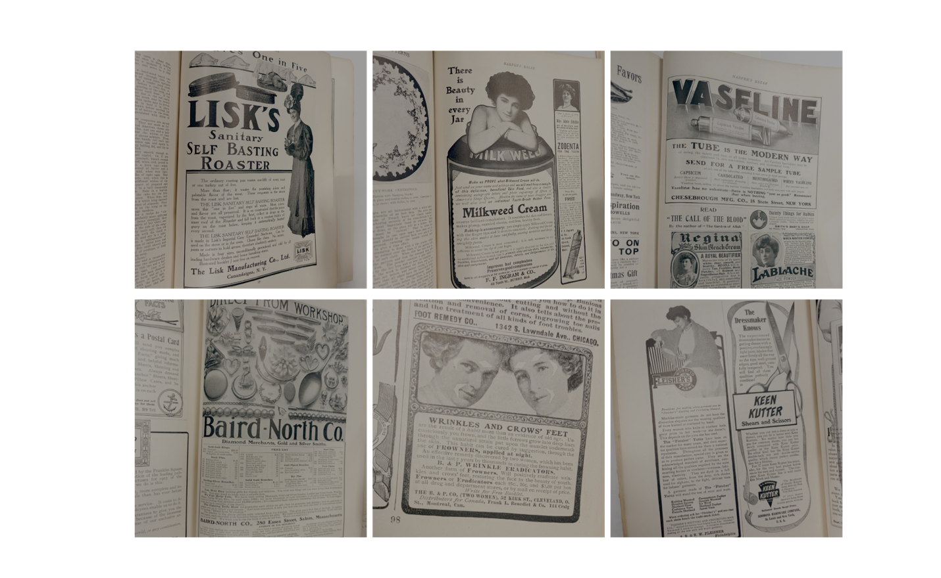Figure 3 Advertising pages from Harper's Bazaar, c. 1895-1910, examined during archival research, Rare Books and Archives Division, Virginia Museum of Fine Arts, Richmond, Virginia. Photographs by author

The typography surrounding these products performs the same work in both periods. On a single page, Vaseline deploys clean bold display type, leveraging highlights and shadows to assert industrial modernity as the dominant voice. Directly beside it, Regina Skin Bleach and LaBlache use ornate script and decorative borders, residual forms performing intimacy reminiscent of an apothecary. The Baird-North advertisement uses hand-lettered workshop letterforms to signal authenticity while participating in mass production. Diagonal compositions create urgency across the page. At the edges, the first gestures toward Art Nouveau appear, an emergent form influenced by nature and organic shapes, is being negotiated in direct response to the overwhelming commerce of the dominant. The nervous consumer of the First Gilded Age and the nervous consumer of the Second are purchasing the same reassurance in the same typographic register.
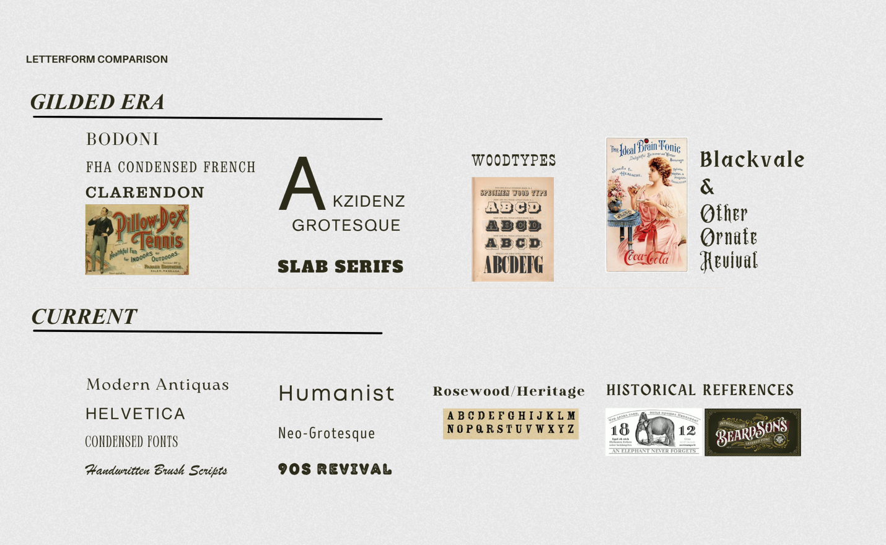
Figure 4 Letterform comparison: Gilded Era typography (top row) and current typographic landscape (bottom row), demonstrating parallel formal responses to analogous socioeconomic conditions. Figure compiled by author.

Figure 4 demonstrates aesthetic similarity amongst two periods that share structural identities. In each period, the dominant consolidates toward legibility, neutrality, and efficiency, presenting its particular formal standard as simply what good communication looks like. The residual reaches backward toward craft, heritage, and authenticity, carrying the nostalgia of when products were more intimately constructed, and the emergent is metabolized before it can fully consolidate, absorbed into the dominant's commercial logic and sold back to the culture that desires reaching something more personal. As Johanna Drucker observed of the First Gilded Age, the language of graphics became a language for and of industry, with the rhetoric of supposedly universal formal principles historically coincident with the need for industrial production. The same rhetoric organizes the current visual landscape. The neutral sans-serif of platform capitalism presents legibility through easily read simplistic forms. The colonial grammar of the universal works in both periods through the same mechanism: acceptance of an ontological landscape concerned with attention, profit, and the precious value of time. The pattern holds and the spiral continues, but somewhere within both periods, hands are still making forms that the dominant cannot fully absorb.
- The Fracture Where Agency Lives: Ontological Shift and the Persistence of the Hand
In 1981, sociologist turned philosopher and cultural theorist, Jean Baudrillard (1929-2007) declared that art had been absorbed entirely into the logic of commodity culture. Baudrillard claimed that contemporary art lost its subversive expression and instead became a spectacle of our capitalist society and a circulation of signs. He argued that art no longer produces meaning but conspires with media and markets in the endless play of imagery and symbols.
However, Baudrillard mistakes the dominant for the whole by observing the absorption and calling it totality. The mistake here is basing his observation on a widely misunderstood Hegelian concept. Georg Wilhelm Friedrich Hegel (1770-1831) was a German philosopher who fundamentally shaped Western philosophy, political theory, and aesthetics. Considered one of the most influential thinkers of the nineteenth century and a central figure in German Idealism, his philosophical system attempted to account for the development of human consciousness, history, culture, and spirit as a unified, dynamic process.
His aesthetic theory is developed most fully in his “Lectures on Aesthetics,” delivered at the University of Berlin between 1820 and 1829 and published posthumously in 1835 from student notes. He constructs three stages of art: The Symbolic Stage, of which is the earliest and most primitive relationship between form and meaning. In this stage, meaning is too large and too undefined for the material form to carry cleanly. An example would be exemplified in Egyptian art such as the Sphinx. The form is monumental and serious, but the content exceeds the form. Something is trying to be said, but the vessel incompletely expresses it. The next stage in his system is The Classical Stage, which is the peak of art in Hegel’s schema. The example here is an ancient Greek sculpture: the human body as the ideal vessel for expressing the ideal of human spirit. The material form and the idea expressed achieve complete harmony. The Romantic Stage is where the content begins to outgrow the form again, but in the opposite direction from the symbolic stage. Here, the content, specifically the inward life of human consciousness, subjectivity, emotion, and spirituality as understood through Christianity and modern thought, becomes too rich, too complex and too interior for any physical form to fully contain. The form starts to break down under the weight of what is being asked to express. In this stage, Hegel sees painting, music, and poetry as dominant creative forms as they are progressively less bound to physical matter and therefore more capable of expressing the interior world. At the furthest end of The Romantic Stage, is where art points beyond itself entirely, and begins to gesture toward philosophy, toward pure thought, and toward a mode of understanding that no longer requires sensory material to operate. This is what Hegel means by “The end of art.” It is not that it loses value or meaning, but rather, it reaches the limit of what it can do as art and begins to require philosophy to complete what it started.
Most popular readings, including Baudrillard’s implicit use of it, take Hegel’s end of art to mean that art has exhausted itself and has nowhere left to go. Baudrillard’s take is that at this point, art moves forward as repetition or simulation. But in the long tradition of the need-to-know versus the implication of creative thought, Baudrillard read Hegel much too literally. For as tough as Hegel’s content is to chew through, it leaves space for the evolution of the reader’s ability to comprehend complex concepts over time, something language cannot do on its own. A sociologist is no stranger to dense material. A philosopher is familiar with formulating thoughts on the abstract. But it is the art historian who is well-equipped to interpret an essence that cannot be articulated by the limits of language and imaginary construct. Here, an art historian can turn a surface read on the concept on its side to point out that Hegel says that art evolves into a philosophical register. The content and the practice do not disappear, but rather, they transcend the container.
It is when art and expression spiritually transcend that it pushes through into a register that no system can fully commodify, because it lives in the expressive spirit of the person creating it. The $29 font package exists because the hand painted sign exists and carries something the purchased font cannot replicate. The copy requires the original. The simulation points back toward the thing it simulates. Baudrillard's death of art is Hegel's saturation: the moment when meaning outgrows every container built to hold it. It is in that transcendence that its realization persists and is carried forward through the hand that is still making.
This tension between art, craft, and design on one side and patronage, production, and commodification on the other is not a modern concept. The medieval scribe and illustrator worked within a social hierarchy, the Renaissance painter worked for papal patronage, and the author relies on its publisher. 19th century British textile designer, William Morris, built a craft revival in direct response to industrial capitalism, and his products became luxury goods for the elite within a generation. The letterpress craftsperson slowed the progress of singular standardization of Times New Roman. The German art and design school, The Bauhaus, was dismantled as a threat to fascism, but in its diaspora, laid the foundation for modern design. The social movement that would eventually become Futurism, called for the dismantling of imperial rule and syntax, both of which would come into manifestation. The hand painted sign becomes the voice of careful crafting. The blackletter tattoo becomes the lifestyle brand. A sleek packaging design signals modern efficiency. The residual is always being chased by the dominant because the dominant knows, even when it cannot articulate why, that what the hand carries is what people desire. The slow nature in which artistic value comes to the surface is not indicative of its weight that keeps power constructs in balance, and its absorption is not evidence that resistance failed. What it is, is evidence of the residual's power, as what gets absorbed is what mattered enough to be worth taking.
This paper does not offer a prediction, but a pattern and a question. If the spiral of time that Emerson described holds, and the evidence assembled here suggests it does, then the period of integration toward homogenization we are currently inhabiting carries within it the conditions for its own reorganization. The peaks are already visible: the pursuit of humanities degrees have dropped, midcentury revival as stylistic preference signifies cool by removing color and pattern, STEM functions as the credentialing language of the current labor economy from under the cultural prestige of scientific rationalism just as industrial labor was once dignified through the morality of duty and honest work. What they signal are the residual periods of reform asserting itself before the next consolidation arrives. The question this pattern cannot answer is what this all means for our society. What it can offer is a valuable perspective that is required for ontological shifting.
It is the uncomfortable power of self-awareness that a theory built heavily on the abstract, living in the abstract, does not create value for a world living. Society may feel as if it is collapsing inward, as it did during the First Gilded Age, but the conditions being lived and navigated by four practitioners whose work grounds this research offers us perspective in slow, albeit active resistance. Over the course of this research, I was generously given the time by Sofie Praestgaard (Philadelphia), Jessie Fora (New York/Philadelphia), Doug Aldrich (New York), and Ross Trimmer (Richmond).
Sofie, an art director who holds a degree in fine arts from University of Pennsylvania, works in branding design. Praestgaard arguably navigates the most complex position of the four. She is inside the apparatus, working within the dominant's institutional framework, creating what clients want while watching it risk drowning in the sea of trends. Within that constraint, she quietly adjusts the dial in visual culture. Her hand adjustments to repetitive and underwhelming font families, inserted into the work sometimes with, and sometimes without, the client's awareness, are micro-interventions in the diffusion chain. She, as well as many other designers doing the same, are the fracture in the system that the system recognizes.
Jessie Fora, a board member of New York’s Scribe Society and a tattooer whose specialty is in lettering, articulates the counter-logic to the dominant's appetite for speed with the simplest possible formulation: slow and steady wins the race. In a visual culture that optimizes for frictionless production and instant legibility, the time Jessie takes in learning and practicing her craft is, in itself, an act of resistance. She speaks of the value of imperfection: the inconsistency in a hand-made letterform shows the artistry of someone with a soul.
The two hand-painted sign artists interviewed, Ross Trimmer and Doug Aldrich, offered two varied perspectives on tradition, the preciousness of craft, and community. Trimmer’s read on ghost lettering is not nostalgic, but paleographic. He reads the layers, structure, and the working method, in the same manner of which I read the Laoan Psalter. Noting that the Depression era sign painter wasn’t a precious, hip artist, but working men trying to survive in the most honest articulation of the conditions of its production. Rather than an aesthetic category, the form of the time carried the pressure of a person who needed to eat, and more than likely, needed a drink to forget the world they lived in. For the artist, the world built on capitalism can be a tough one to navigate.
Aldrich, who graduated from The Pratt Institute, shared that he almost gave up the very career that built his life. As an isolated artist, feedback from clients untethered his enthusiasm, leaving him feeling less convinced of his artistic ability, and contributive value. By a stroke of luck, he found himself at a hand-painted sign workshop, filled with contemporaries. He was surprised by the unsolicited praise and notes of how he inspired his fellow artists. He had no idea how far his style travelled, how much influence he had on others, and how much other practitioners shared in his passion and doubts.
Johanna Drucker, whose work on visual epistemology brought us closer to its understanding than most design theorists, diagnosed the condition with precision but proposed a solution that reproduced its terms. She brings an attuned awareness of instability of humanist design, but in her proposed solution, her critique was absorbed back into the logic of systemization. While scoffing at Dunne and Raby and others for their activist critical design being too performative, she is blinded that her judgment of others trying something different is exactly how homogenization flourishes. She calls for interpretive openness while verbally rolling her eyes at other designers' attempts and calls the entire act of individual interpretation as exhausting and insufficient. Why bother trying if you can’t get it right the first time?
What the brilliant body of Graphesis: Visual Forms of Knowledge Production does well is arguing that the current system of visual knowledge production operates under the false claim of observer-independent objectivity, meaning it presents its particular organization of knowledge as simply how data looks, as neutral and universal. She calls for a humanistic approach that builds uncertainty and interpretation into the system. She arrives at a solution that remains within the logic of systemization itself. A more capacious dominant is still the dominant. To call for a new interface to account for the unquantifiable only illustrates that a well-intentioned person who builds a more inclusive system still remains the architect of that system and has not actually decentered anything; they've just made the dominant more comfortable with itself.
What Graphesis offered to this research was invaluable, but this paper proposes something different. It would be gregarious to propose the overthrow of a system structure that has established itself over centuries. The suggested ontological shift then also becomes a dreamer’s dream in the forced submission of sleep. But what if the proposal is not an overhaul, or redesign, but a shift in perspective? The research conducted offers historical evidence of a system that persists, but has vulnerabilities, and a long tradition of creative, inventive, and expressive agency despite socio-economic and political pressures. The perspective isn’t an application to the system, but from inside of it, to what changes are possible within it.
Ontology asks not what things are, but what kinds of things can exist. Once the apparatus is visible and the diffusion chain is legible, once the habitus is recognized as learned rather than an organic occurrence, you are no longer entirely subject to the system's terms. This is why creators and artists matter, not as romantic figures preserving a dying craft, but as evidence that certain forms of knowledge and resistance remain structurally beyond the reach of the dominant.
The awareness that the system exists and how it operates is the precondition for agency. You cannot by-pass lived reality, but you also cannot resist a system you can’t see. This body of research serves so that the question of agency becomes askable. Power, for Foucault, has no single source and requires no coercion; that also holds true for meaning. If existence precedes essence, then we can be reassured that meaning accumulates, persists, and carries forward in forms that no system fully intended and no system has ever fully contained. The written mark does not exhaust itself. It is meaning's most patient, most reproductive, and most embodied archive. What the accumulation of evidence in this paper ultimately demonstrates is that the barometer lives inside the thought and speech’s forms materialized, measuring what institutions could not afford to name and carrying what no system has ever fully contained. To read it is an act of orientation and a reminder that the human condition across periods is the same: more stubborn than any apparatus.

Bibliography
Aristotle. Categories and De Interpretatione. Translated by J.L. Ackrill. Oxford: Clarendon Press, 1963.
Arnheim, Rudolf. Visual Thinking: 35th Anniversary Printing. Berkeley and Los Angeles: University of California Press, 1969.
Barthes, Roland. "The Death of the Author." In Image-Music-Text, Translated by Stephen Heath, 142-148. New York: Hill and Wang, 1977.
Baudrillard, Jean. The Conspiracy of Art: Manifestos, Interviews, Essays. Edited by Sylvère Lotringer. Translated by Ames Hodges. New York: Semiotext(e), 2005.
Baudrillard, Jean. Simulacra and Simulation. Translated by Sheila Faria Glaser. Ann Arbor: University of Michigan Press, 1994.
Bourdieu, Pierre. Distinction: A Social Critique of the Judgement of Taste. Translated by Richard Nice. Cambridge: Harvard University Press, 1984.
Derrida, Jacques. Of Grammatology. Translated by Gayatri Chakravorty Spivak. Baltimore: Johns Hopkins University Press, 1976.
Drucker, Johanna. Graphesis: Visual Forms of Knowledge Production. Cambridge: Harvard University Press, 2014.
Emerson, Ralph Waldo. "Circles." In Essays: First Series. Boston: James Munroe and Company, 1841.
Emerson, Ralph Waldo. "Self-Reliance." In Essays: First Series. Boston: James Munroe and Company, 1841.
Foucault, Michel. Discipline and Punish: The Birth of the Prison. Translated by Alan Sheridan. New York: Vintage Books, 1975.
Foucault, Michel. The Order of Things: An Archaeology of the Human Sciences. Translated by Alan Sheridan. New York: Pantheon Books, 1970.
Fraser, Steve. The Age of Acquiescence: The Life and Death of American Resistance to Organized Wealth and Power. New York: Little Brown, 2015.
Hegel, Georg Wilhelm Friedrich. Aesthetics: Lectures on Fine Art, Volume I. Translated by T.M. Knox. Oxford: Clarendon Press, 1975.
King's College London, Faculty of Arts and Humanities. "Times New Roman." YouTube video, January 26, 2017. https://youtu.be/v2jmp6yp0Z0?si=zdGeeWDN0N7QnYNC.
Latour, Bruno. Reassembling the Social: An Introduction to Actor-Network Theory. Oxford: Oxford University Press, 2005.
Lupton, Ellen, and Abbott Miller. "Theory." In Design Writing Research: Writing on Graphic Design, London: Phaidon Press, 1996.
Piketty, Thomas. Capital in the Twenty-First Century. Translated by Arthur Goldhammer. Cambridge: Harvard University Press, 2014.
Saussure, Ferdinand de. Course in General Linguistics. Edited by Charles Bally and Albert Sechehaye. Translated by Wade Baskin. New York: Philosophical Library, 1959.
The Gilded Age (American Experience). Documentary film. Directed by Sarah Colt. PBS, 2018.
Wagoner, Brady, and Lisa Herbig. "Thinking Through Historical Analogies: A Longitudinal Analysis of Sense-Making During the Pandemic." Integrative Psychological and Behavioral Science 59 (2025) https://doi.org/10.1007/s12124-025-09942-3.
White, Richard. "Our Gilded Age." Journal of the Gilded Age and Progressive Era 19, no. 3 (2020).
Williams, Raymond. Marxism and Literature. Oxford: Oxford University Press, 1977.
Interviews (Primary Sources)
Aldrich, Doug. Interview by Sophia Hornyak. Brooklyn, New York City, April 2, 2026. Transcript in possession of the author.
Fora, Jessie. Interview by Sophia Hornyak. Philadelphia, March 26, 2026. Transcript in possession of the author.
Praestgaard, Sofie. Interview by Sophia Hornyak. Philadelphia, March 9, 2026. Transcript in possession of the author.
Trimmer, Ross. Interview by Sophia Hornyak. Richmond, March 29, 2026. Transcript in possession of the author.
Archival Materials Consulted
Harper's Bazaar, c. 1895-1910. Rare Books and Archives Division, Virginia Museum of Fine Arts, Richmond, Virginia. Examined February 10, 2026.
Kislak Center for Special Collections, Rare Books and Manuscripts, University of Pennsylvania, Philadelphia. Primary source materials examined with assistance of Dr. John Pollock, Curator. March 12, 2026.

J.L. Ackrill translation in Aristotle's Categories and De Interpretatione, Clarendon Press, Oxford, 1963, section 16a3-8.
Michel Foucault, The Order of Things: An Archaeology of the Human Sciences, trans. Alan Sheridan (New York: Pantheon Books, 1970), 78.
Ralph Waldo Emerson, “Self-Reliance,” Essays: First Series, 1841.
B. Wagoner and L. Herbig, "Thinking Through Historical Analogies: A Longitudinal Analysis of Sense-Making During the Pandemic," Integrative Psychological and Behavioral Science 59 (2025): 68.
Rudolf Arnheim, Visual Thinking: 35th Anniversary Printing. (Berkeley and Los Angeles, California. University of California Press, 1969), 232.
Ferdinand de Saussure, Course in General Linguistics, ed. Charles Bally and Albert Sechehaye, trans. Wade Baskin (New York: Philosophical Library, 1959), 67.
Pierre Bourdieu, Distinction: A Social Critique of the Judgement of Taste, trans. Richard Nice (Cambridge: Harvard University Press, 1984), 11, 169-172.
Foucault, Michel. Discipline & Punish: The Birth of the Prison, trans. by Alan Sheridan. (New York: Vintage Books 1975)
Michel Foucault, The Order of Things: An Archaeology of the Human Sciences, trans. Alan Sheridan (New York: Pantheon Books 1970), 168-170.
Bruno Latour, Reassembling the Social: An Introduction to Actor-Network Theory (Oxford: Oxford University Press, 2005), 46.
Raymond Wiliams, Marxism and Literature (Oxford: Oxford University Press, 1977), 121-127.
Jacques Derrida, Of Grammatology, trans. Gayatri Chakravorty Spivak (Baltimore: John Hopkins University Press, 1976), 49-73.
Roland Barthes, “The Death of the Author,” in Image-Music-Text, trans. Stephen Heath (New York: Hill and Wang, 1977) 142-148.
Ralph Waldo Emerson, “Circles,” in Essays: First Series (Boston: James Munroe and Company, 1841).
Figure 1 sources: Pre-Carolingian Minuscule: Liber scintillarum, 8th century, Zentralbibliothek Zürich, Ms. C 65, fol. 9v; Carolingian Minuscule: Psalterium, France, end of 9th century, Zentralbibliothek Zürich, Ms. Car. C 161, fol. 163v; Gothic Cursive: Charter of Lütold of Regensberg, 1285, Klosterarchiv Einsiedeln, K.P.1; Humanist Script: Hans Füssli, Schweizer- und Zürcherchronik, Zentralbibliothek Zürich, M. K 39 Bullinger, fol. 125v. All manuscript images accessed via Ad Fontes, University of Zurich, https://www.adfontes.uzh.ch/en/tutorium/schriften-lesen/schriftgeschichte/karolingische-minuskel; Times Old Roman and Times New Roman: New York Public Library Digital Collections, https://www.nypl.org/blog/2014/12/09/times-new-roman.
Materials accessed with the assistance of Dr. John Pollock, Curator, Kislak Center for Special Collections, Rare Books and Manuscripts, University of Pennsylvania, Philadelphia, Pennsylvania, March 12, 2026.
The Second Gilded Age as a scholarly framework is developed across several works. See Thomas Piketty, Capital in the Twenty-First Century, trans. Arthur Goldhammer (Cambridge: Harvard University Press, 2014); Steve Fraser, The Age of Acquiescence: The Life and Death of American Resistance to Organized Wealth and Power (New York: Little Brown, 2015); and Richard White, "Our Gilded Age," Journal of the Gilded Age and Progressive Era 19, no. 3 (2020).
Harper's Bazaar issues examined during primary source research visit, Rare Books and Archives Division, Virginia Museum of Fine Arts, Richmond, Virginia, February 10, 2026. Note: the magazine was originally published as Harper's Bazar with one 'a' until 1929 when it became Harper's Bazaar.
Johanna Drucker, Graphesis: Visual Forms of Knowledge Production (Cambridge: Harvard University Press, 2014), 30-31.
Jean Baudrillard. The Conspiracy of Art: Manifestos, Interviews, Essays, ed. Sylvère Lotringer, trans. Ames Hodges (New York: Semiotext(e), 2005).
Georg Wilhelm Friedrich Hegel. "Hegel’s aesthetics: Lectures on fine art, volume I." Trans. Tim Knox (Oxford: Clarendon Press) 1975
Sofie Praestgaard, interviewed by Sophia Hornyak, Philadelphia, March 9, 2026
Jessie Fora, interviewed by Sophia Hornyak, Philadelphia, March 26, 2026
Ross Trimmer, interviewed by Sophia Hornyak, Richmond, March 29, 2026
Doug Aldrich, interviewed by Sophia Hornyak, Brooklyn, New York City, April 2, 2026
Johanna Drucker, Graphesis: Visual Forms of Knowledge Production (Cambridge: Harvard University Press, 2014), 176-178.

