Brightpoint Community College and Virginia Commonwealth University

Theatre, Cosplay, and the Art of Playing Dress-Up

Bailey Clark
Mellon Research Fellows 2025-26
Mentor: Dr. Paula Winn
20th April 2026
INTRODUCTION

I graduated high school without an inkling of what I wanted to study in college, let alone do with my life. It would take another few years for everything to click into place, but I had already been given the initial catalyst for my entry into the world of theatrical costuming: a ticket to Otakon 2019 in Washington, D.C., my first anime convention. Having been huge nerds and Halloween costume-overachievers our whole lives, my brother and I jumped at the opportunity to give cosplay a try. It was challenging, exhausting, and frustrating; but I will never forget the elation I felt when I transformed a plain thrifted sweater into the Pokémon trainer Gloria's sweater with some strips of fabric, needle, thread, and a prayer.
The convention itself was a dream. Never before had I felt such a sense of community and camaraderie (especially when someone would yell, "I love your Gloria cosplay!" from across a crowded hall, and even ask for a picture!). I was dazzled and inspired by the thousands of costumes made by people at every experience level. I even saw a (particularly well made) fursuit for the first time and bought a pair of generic cat paw gloves which would inevitably send me down the furry path during the COVID lockdown.
It took a few more years of conventions, building fursuits, and working as a mascot performer at Kings Dominion before I finally decided to return to college and pursue a costuming degree. During my first semester back, before I had even taken Brightpoint's intro to costuming class, I was approached and encouraged to apply to the Mellon Research Fellows program. I knew right away that I wanted to research something related to costumes and theatre, but I didn't know if I wanted to focus solely on theatre, perhaps look into cosplay, or somehow combine the two. Then and there, I remembered a cosplay design I had tinkered around with a few years prior. I wanted to cosplay Mightyena, my favorite Pokémon, but in the style of the hyenas in Julie Taymor's "The Lion King" stage musical. "The Lion King" is an unmistakable cornerstone in my love for theatre, costuming, puppetry, and all kinds of visual and performing arts; I will leave it at that, as I cannot possibly continue discussing my love for this musical without adding another thirty or so pages to this document.
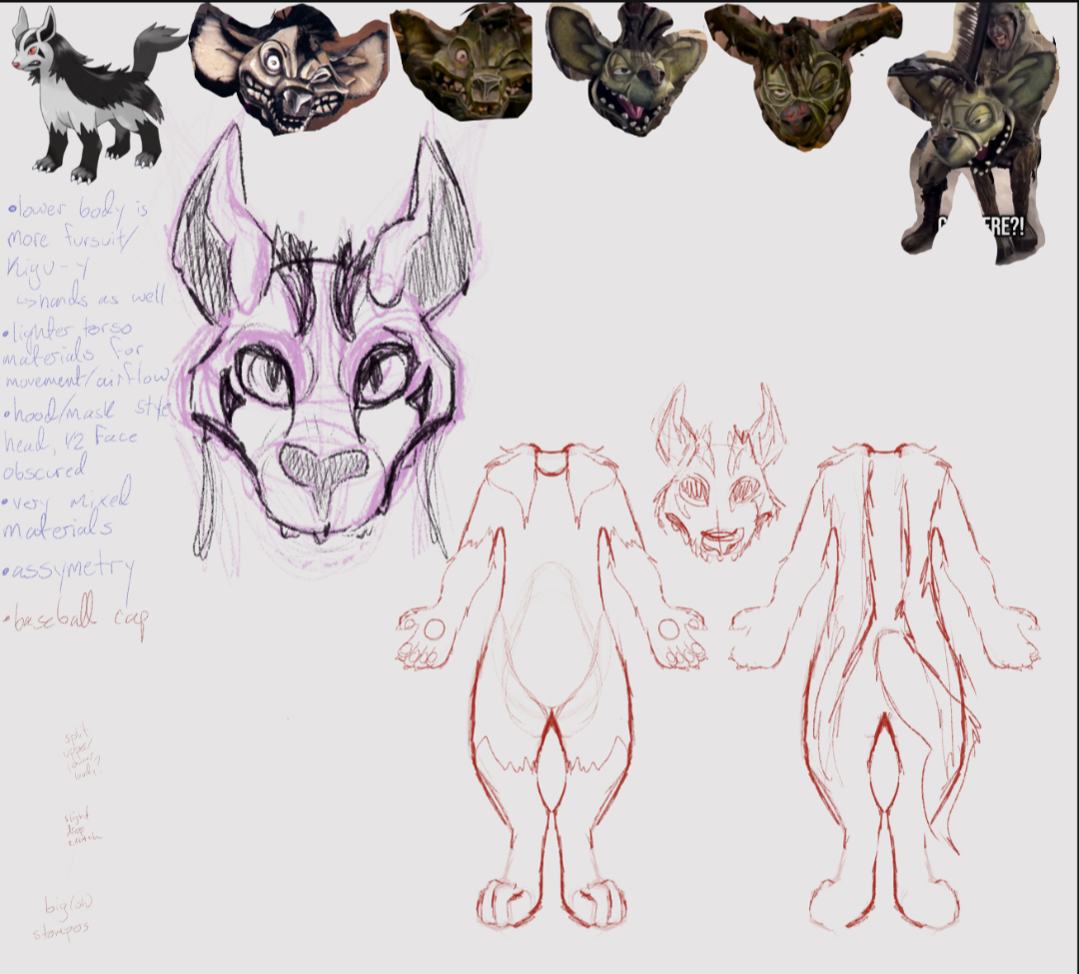
Having this design as a launch pad, I decided that my research would be focused on the intersection of different types of costuming, such as theatre and cosplay, as well as considering why humans are so keen on "playing dress-up". Cosplayers often receive flack for having a "childish" or "nerdy" hobby, but I never understood this criticism. It is widely accepted that people wear costumes on Halloween, but does it have to be restricted to one day of the year? One doesn't sneer at actors simply for wearing their costumes on stage, presumably because they're fulfilling a purpose of storytelling and entertainment. But is a Halloween costume not entertainment? Are cosplayers not sharing stories through their costumes? And where do we draw the lines between theatrical productions, cultural/religious rituals, and wearing something purely for personal enjoyment? Every single garment and accessory we wear tells the world some kind of story about us.
Director Peter Brook defined theatre as a person doing an action in a space with someone watching. If I were to go out in public and just stand around wearing an eye-catching costume, people would surely stop and watch. Is that not theatre? Even those unfamiliar with theatre can understand the basic premise of theatrical costumes. They tell us a bit (a lot) about the characters and help the audience distinguish one from another. Cosplay, on the other hand, can be harder to comprehend. What looks to outsiders like nerds playing dress-up is so much more than just nerds playing dress-up; it is an incredibly deep and complex subculture dating all the way back to 1876 when author Jules Verne held a science fiction-themed masked ball to which attendees were encouraged to wear costumes based on fictional characters (Winge). 150 years later, cosplay has gone from a niche, misunderstood hobby to something widely recognized and practiced. There are still misconceptions and stigmas surrounding it, and there probably always will be; however, it has since become generally more accepted in mainstream pop culture.
Over the past several months, I have used my personal experience in both the theatrical and cosplay worlds, as well as my growing knowledge from my current costuming studies, as a basis for an exploration into the many ways in which humans choose to dress themselves as a method of storytelling, self-expression, and so much more. Countless intersections between cosplay and theatre have made themselves known through my research and lived experiences: I have found that cosplay itself is a form of theatre.

THE COSTUME MAKES THE CHARACTER

"The costume designer curates the visual external body of the character while the actor gives life to its heart, mind, and the physical body in motion" (Amidei). While costume designers analyze the script to ensure that each design complements its respective character, the completed costume does just as much to inform the actor of how a character exists in their world. Most directors and costumers I've worked with have said something to the effect of "the shoes make the character". From years of acting experience, I can attest that being in the right clothes (especially the shoes) is often the final push I need for my character to come to life.
In "Sinners", directed by Ryan Coogler, Michael B. Jordan wore different shoe sizes when portraying each of the twin brothers, Smoke and Stack. He wore larger shoes for Smoke, the blue-clad, cool headed, calculated brother, so that every step had to be more careful and intentional. He wore smaller shoes for Stack, the red-clad, energetic, charismatic brother, to make himself more fidgety and restless. Though never seen by the audience, this small step helped Jordan give even more depth to an already impressive performance (Salisbury).
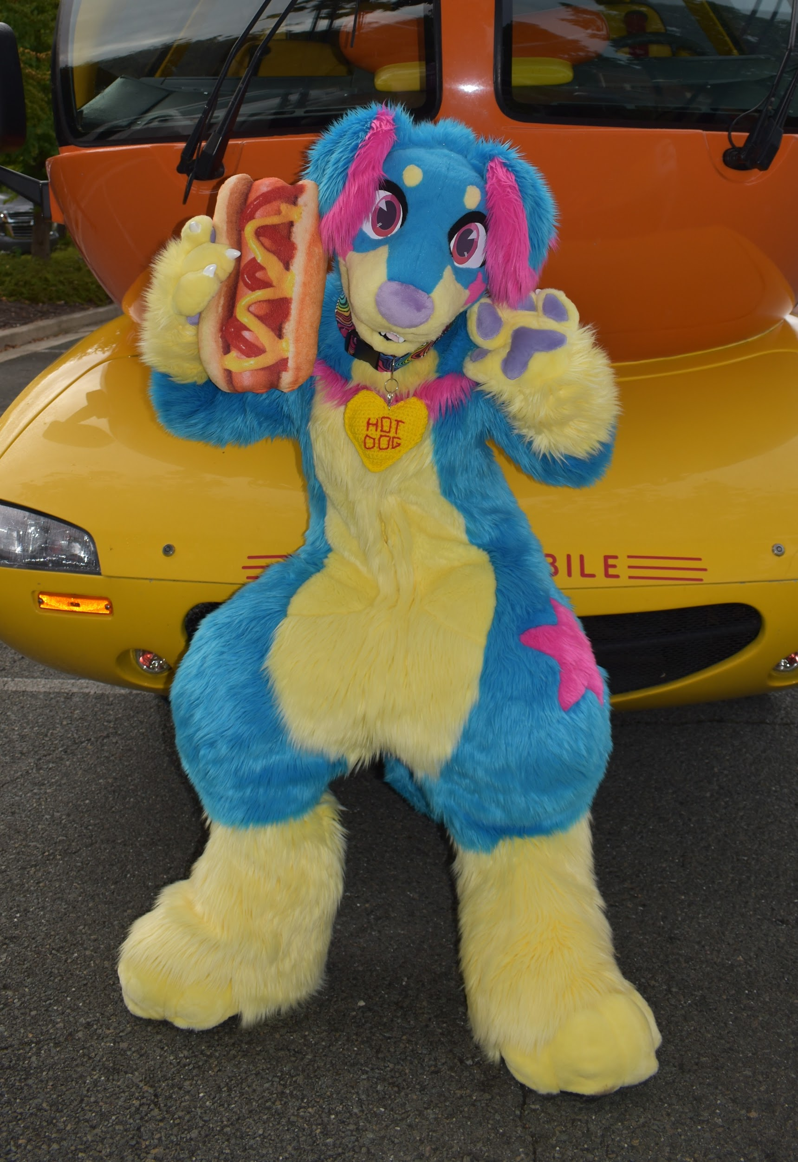
In a similar vein, one of my fursuits, known as Dot the dachshund, has massive, stompy feet, and clunky padding on the legs to give her the silhouette of a big, cartoony puppy. This limits my mobility in the costume, but I've learned to use it to my advantage when performing this character. I walk (waddle, really) with a wide gait, dramatically swing my hips (which conveniently makes her tail wag), and hold my arms out by my sides with my wrists flexed up (a traditionally "girly" pose in the mascot world). I would look absolutely ridiculous doing this in my regular clothes, but when my body is hidden inside of such a bulky costume, it brings her to life and exemplifies her goofy, ditzy character.
Typically, cosplay does not involve much in the way of acting. There are no scripts, no grand performances to be given, just people embodying their love of a character for a day. However, in the world of cosplay competitions (something I have yet to experience in-person), there exists something known as the masquerade. Many cosplay contests are craftsmanship contests, meaning the scoring is based entirely on the construction of the costume. However, some have a masquerade section in which entrants are judged both on their craftsmanship as well as performance of a skit they themselves have written and rehearsed.
Based on the examples I have seen online, mostly thanks to YouTuber Sarah Spaceman, cosplay masquerades are a beautiful example of the intersections that exist between cosplay and theatre. Some skits are like a live-action rendition of a scene from the source material and some are more like silly fanfictions being acted out on stage. I can't help but make a connection to every Shakespeare production I've seen. Each one can generally be categorized in the same way: true to the source material, or, "what if we made it weirder?"
Separate from the masquerades, mini theatrical moments are still happening everywhere in the convention center. When one attendee recognizes another's cosplay, it is common practice to reference something from the source material rather than just saying, "Hey, I like that character too!". Just the day before writing this sentence, I went to a renaissance fair with my brother who recognized someone cosplaying the character Solaire from the "Dark Souls" game series. My brother said "Solaire!", to which the cosplayer responded with the character's signature catchphrase, "Praise the sun!", and the interaction was over. In that brief moment, a positive human connection was formed through a costume and a line. Whether the costumed participant is a paid actor or simply a passionate hobbyist, this act of connection through storytelling is ever-present in our lives.
In furry conventions, this kind of interaction relies more on a fursona's species rather than individual character, such as the time I was subjected to playful hisses and jeers when I walked into a bird meetup dressed as a cat, with the man who held up a large tennis ball and asked if I wanted to play fetch while dressed as a dog, or the children who bravely brandished their toy swords at me in my dragon costume at the renaissance fair.
Interestingly enough, gender presentation often plays a role in costumed performances. In ancient Greek theatre, women could not be actors, so all female roles were played by men in distinct feminine masks. The existence of modern drag shows proves that playing the "role" of a different gender has not gone out of fashion. Crossdressing is extremely common in cosplay spaces where it is sometimes referred to as crossplay (Winge). Research done in furry spaces by Satinsky and Green showed that a vast number of furries also wear fursuits of a different gender presentation than the one they show in their day-to-day lives. After creating and wearing fursuits with varying gender presentations, I found myself questioning my own gender. The ability to play with my gender in such a manner unmistakably played a role in my personal gender journey and eventual transition.Similarly to exploring one's gender through costuming, masks are often a vital part of putting oneself into a different identity. It can be argued that any costume acts as a sort of "mask" under which the wearer hides their regular self, but I want to focus on actual face coverings. Once again, ancient Greek theatre was known for its use of masks, though masks have been used worldwide since, seemingly, the dawn of mankind. The usage of masks hasn't changed much since then: the wearer uses the mask to portray a character, a spirit, a concept, etc. and hide their own identity. Masks on stage have the caveat of hiding the actor's facial expressions, but skilled performers learn to communicate with their bodies instead, similarly to how a fursuiter will shake their hips to "wag their tail" to show happiness in lieu of a smile. As John Mack said in reference to a children's cartoon mask sold at Japanese festivals,
"...the reserved (public) persona can be put to one side, as donning the mask of humorous character releases those inhibitions which normally restrain public behavior. [...]the child's attitude is not dissimilar to that of the Nō actor in the dressing room as he prepares to adopt the whole character he is about to portray on stage. A single-mindedness of purpose is evident in both as they prepare to enter, however briefly, a world apart from the mundane reality of life."
From my own experience in fursuiting, mascotting, and even scareacting at a haunted house, I know all too well the feeling of mischief that overcomes you when you don a mask. There is something about having my face hidden that releases my inhibitions and allows me to interact with others in a more relaxed, daring manner than I would bare-faced. Though I never had an actual mask as a scareactor, the dramatic makeup and costume gave me a similar confidence. Once I became a makeup artist for the same event, I occasionally witnessed the actors being less confident in their scares when their makeup was lighter; i.e., when they looked more like their usual selves.
Since a scareactor cannot scare without a guest walking through their maze, as a cosplayer cannot express their love for a character without someone to share it with, and as an actor cannot perform without an audience, it goes without saying that theatre is an inherently collaborative art. It could be as simple as one actor and one observer, but in most cases, the production of a show can involve hundreds of people in different departments coming together to create one piece of art.
All art is based on something that already existed. One artist is inspired by another, who was inspired by another, who was inspired by something in nature or history, for example. Large-scale shows require a shop full of costumers who have all learned from each other and other costumers in order to design and build all of the necessary costumes. A vast amount of the cosplay material that exists online, aside from photos and videos of finished cosplays, is tutorials and guides made by people wanting to share their craft with the world.
I myself utilized the work of several other artists to create my costume. I started with the work of Julie Taymor and Ken Sugimori (a Pokémon designer and art director), as well as a hand paw pattern by FreakHound Studios, a base for the feet sculpted by MaskMutant, and .STL files for 3D printing the teeth and claws by Thunderhowl and KegawaCreation, both found through the Cults3D website. Of course, I must also thank my wonderful mother for assisting me with some of the hand sewing to save on time.
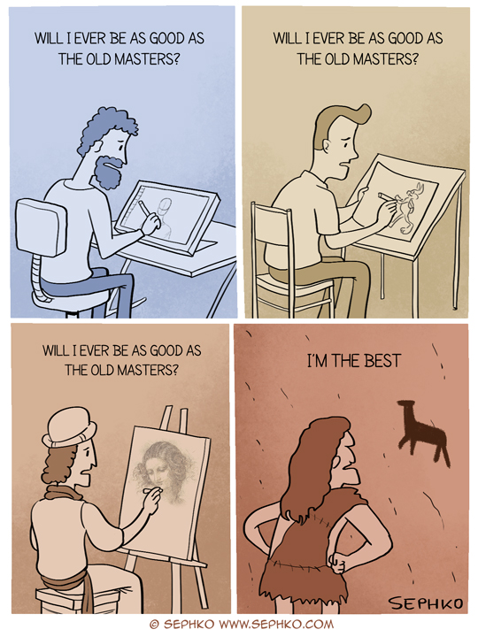

When I entered this program, I pictured myself turning in a perfectly chiseled documentation of the research I had done, carefully picked apart and inspected with a fine-tooth comb several times over. However, as I finalize this project, I'm finding that this is only the first step. I researched this topic and spent as much time building the costume as I possibly could with everything else happening in my life at the same time, but that doesn't mean that I have to stop here.
I never considered myself the type to do formal academic research. It always felt too scary, or something that only the “Very Smart” people could do. I now know just how wrong I was, and how exciting it is to research something that I truly love. As I walked down the path of my research, I passed countless rabbit holes that I had to ignore for the sake of time and conciseness. I fully intend to continue down this path and, now that there are no more deadlines, spend as much time as I please investigating these rabbit holes. I dream of finding myself in an unending spiral of, "If that's the case, then why is this? If this is the case, then why is that? And why is that?" And so on and so forth.
Theatre, cosplay, and costumes mean the world to me. As I continue my studies at VCU, I'm even more excited by the idea of diving further into the how and why of it all. Just as I had touched on the topic of gender presentation, there's so much more to say about the psychology and anthropology behind costumes.
But, until then…
BUILDING A COSTUME

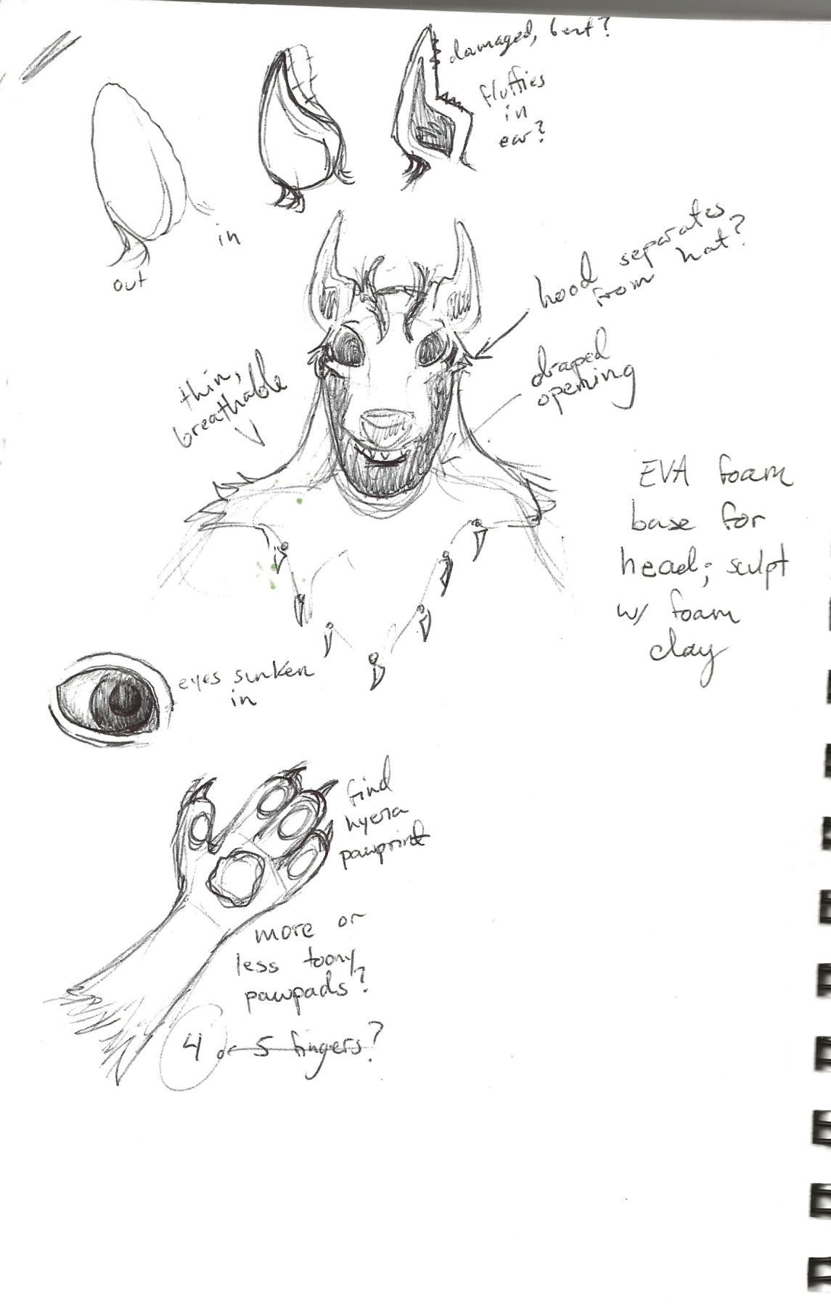
Step one: research! Whether you're designing original costumes from scratch or trying to make your cosplay as accurate to the source as possible, you have to gather plenty of reference images to use throughout the process. I had images of the official Mightyena art as well as several different photos of Taymor's hyenas at the ready as I drafted my design.
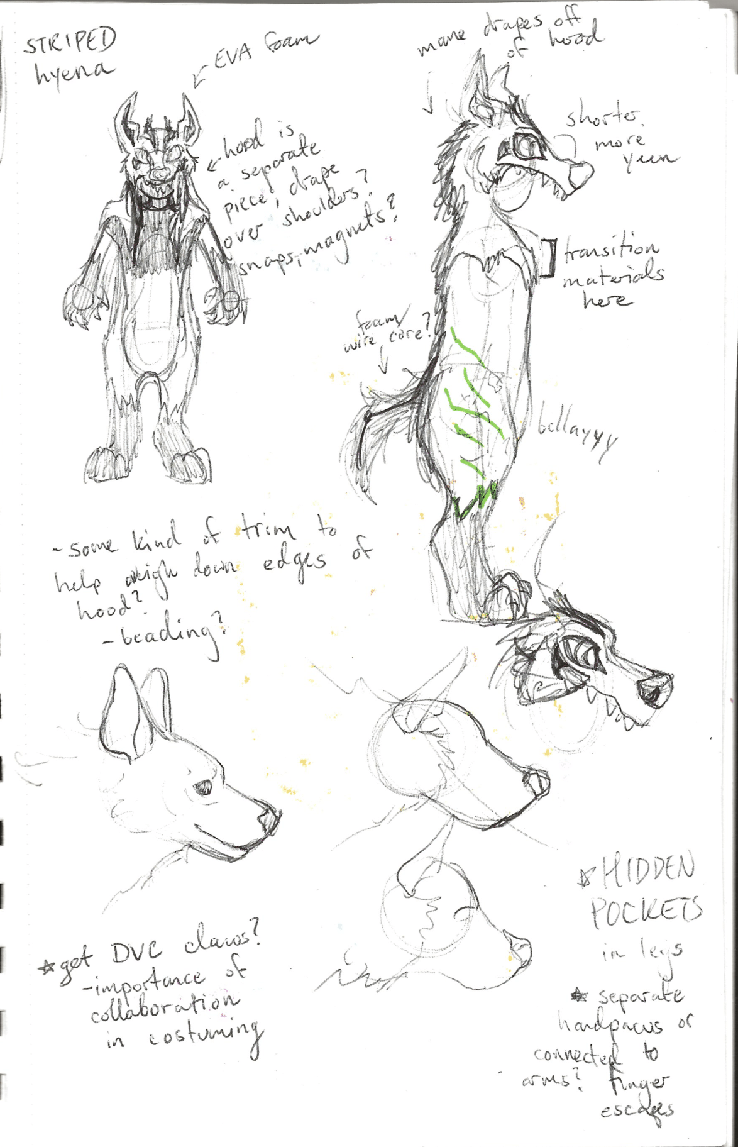

The advent of social media such as Instagram and TikTok have been game changers for cosplayers. Not only is it infinitely easier to share one's work and entice outsiders into the community, but it gives us a better look into how costumes are constructed. This goes doubly for stage costumes which are usually only seen from far away and in dramatic lighting. Noluthando Sithole, an actress who portrayed the hyena Shenzi in the German production of "DER KÖNIG DER LÖWEN", has posted several videos showing various angles of the hyena costumes in bright lighting. This gave me an excellent reference of the costumes that I never would've gotten even from a front-row seat.
While both Mightyena and the hyenas are quadruped, I chose to keep this costume biped for the sake of my sanity and spine. This humanization of non-human characters is considered a form of "moe anthropomorphism", or "gijinka", an art style that is very common in Pokémon fanart and cosplay. However, I did not want this to be an entirely humanized design: I leaned heavily into fursuit design and building techniques for the body, hands, and feet. Before I started my costuming studies, I was an entirely self-taught sewist, and most of my experience came from making fursuits. I fully consider fursuits a form of cosplay, the only major difference being that fursuits are usually original characters, but many "cosplay fursuits" exist of characters from external media, such as Pokémon. Given my history, I couldn't possibly do this grand exploration of costuming styles without including my personal favorite.
One major caveat of fursuits is their weight and warmth. A common joke in the furry community is that we like to run around at conventions wearing expensive carpets. I considered making the entire costume a traditional fursuit, but ending up swapping the head for something more theatrical. Taymor's designs have a very rustic, wooden look, which would be incredibly difficult to emulate with faux fur. In addition to the large puppet-costumes worn by a majority of the hyenas in the musical, there are hyena dancers who wear lightweight dance wear and half-masks to allow for more freedom of movement. I chose to emulate these half-masks both as a nod to Taymor's work and to give myself a slightly less stuffy costume to wear at conventions.

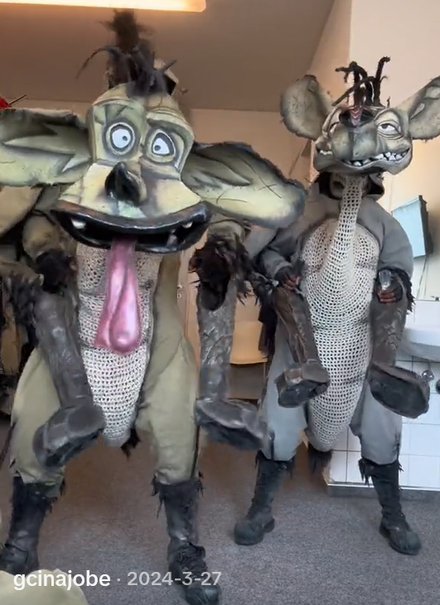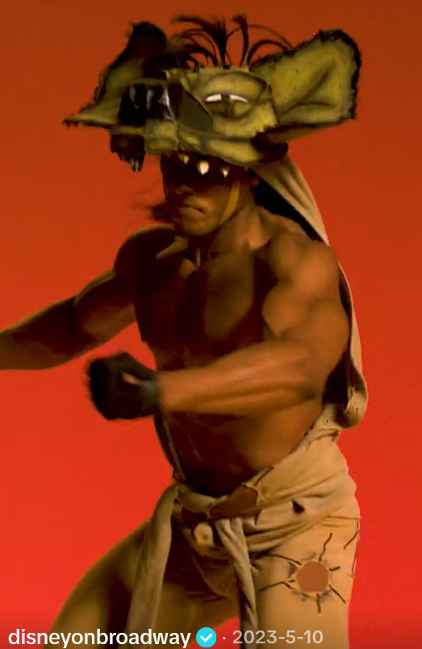
@Gcinajobe, TikTok @Disneyonbroadway, TikTok

This head went through a massive trial-and-error process as I experimented with different methods to get the look that I wanted. It went a bit like this: mini clay mockup -> covered it in masking tape to create a pattern -> sized up said pattern -> built a frame out of EVA foam -> hated how it looked -> reshaped it with upholstery foam -> taped it again -> built an EVA foam frame out of the new pattern -> liked that one -> added some more upholstery foam for additional shaping -> fabric mache'd a layer of canvas on top to smooth out the cracks between the foam panels. Pretty simple.
I then did a second round of fabric mache with old cotton scraps, intentionally overlapping frayed edges for a more interesting look. Then came the many, many, many layers of paint: airbrushed, drybrushed, washed, and spattered. The hood consists of a layer of dyed canvas and a stretchy knit fabric that was cut and distressed for texture. Again, I opted out of fur on the head to reduce weight and increase ventilation.
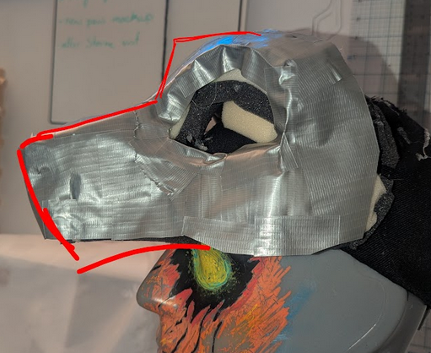
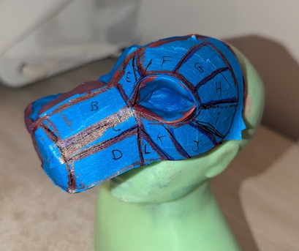
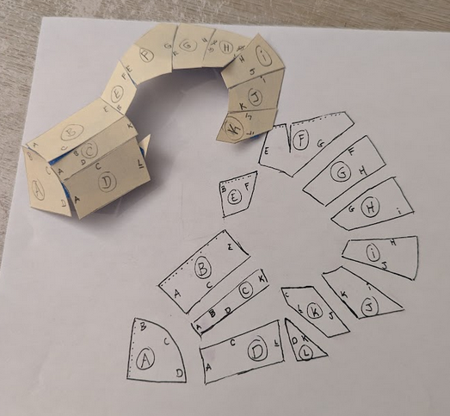

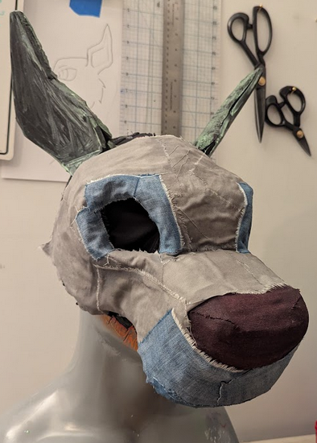
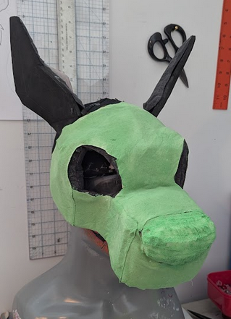
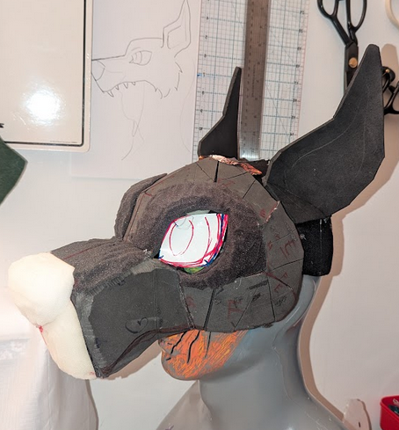
I used a new pattern by FreakHound Studios for the hands. I have attempted to make my own pattern for fursuit hand paws in the past, but I found that it was far too time consuming of a process for the sake of this project. Fortunately, many creative types are eager to share their methods with the world.
This process involved tracing and cutting out approximately sixty different pieces, and then hand sewing them all together. Machine sewing was certainly a possibility, but with how tiny and tedious some of these pieces were, I opted for hand sewing, as it won't eat the tiny pieces as my machine sometimes likes to do.
Just as I chose to use a half-mask instead of full fursuit head for the sake of comfort, I left intentional holes in the gloves, known as finger escapes, so I can use my phone without having to take the whole glove off.
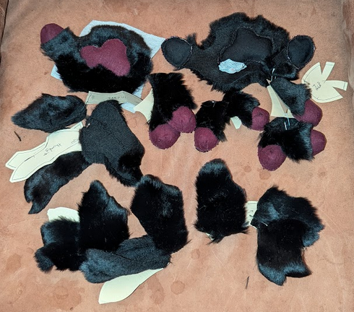
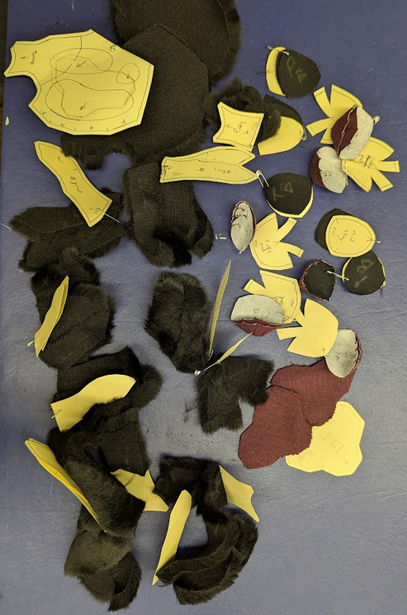

Making feetpaws tends to be one of my least favorite parts of the process. In order to speed things up (and celebrate the spirit of collaboration, of course), I took the footpaw bases I had purchased from the artist MaskMutant several years ago, intending to use them for another project, to build off of. All I needed to do was reinforce the sole with a stronger material, glue some slippers to the inside, and slightly reshape the toes with foam, and I had a base ready to pattern and fur. No annoying carving required.
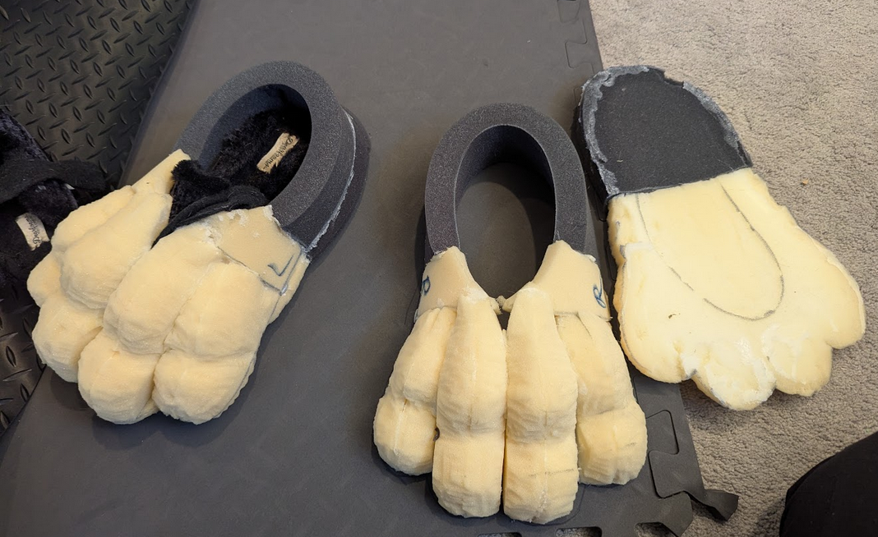

In order to make the bodysuit portion of a fursuit, it is common practice for the client to make a "duct tape dummy" by having friends wrap them up in duct tape while wearing a disposable painter's suit, cutting it off of themselves, and sending it to the fursuit maker in lieu of measurements. I prepped a duct tape dummy for a bodysuit in preparation for "phase 2" of this project, but with the massive amount of time it takes, I decided to prioritize other parts while also focusing on the research portion. I padded the dummy to achieve the dramatic leg shape I wanted, taped over that again, and drew the pattern on. Once it's time to start building the body, I can trace those pattern pieces directly onto the fur and sew it as I would any other garment.
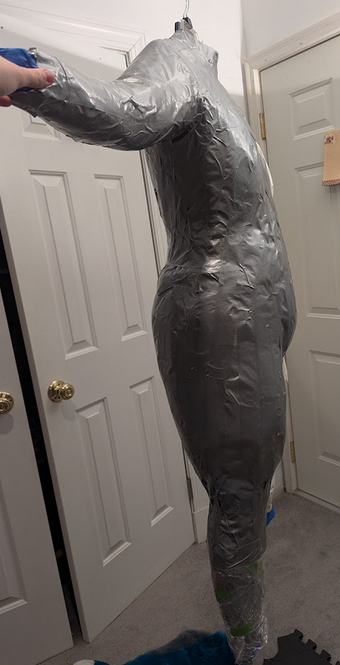
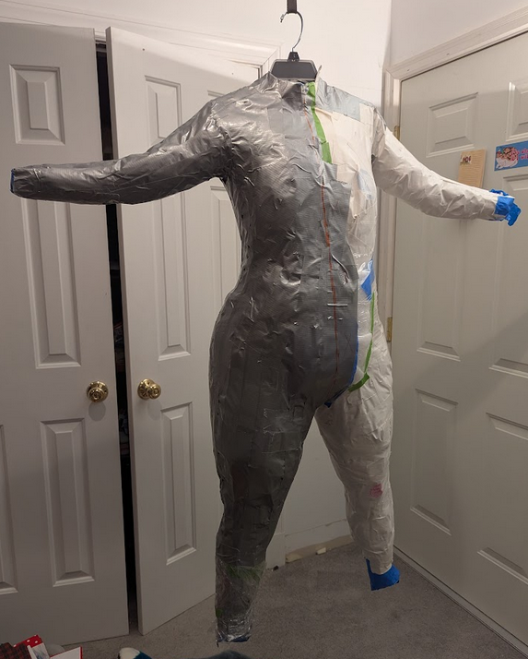

I eagerly look forward to finishing this build and taking it to Otakon 2026, the convention that started it all, this coming August.

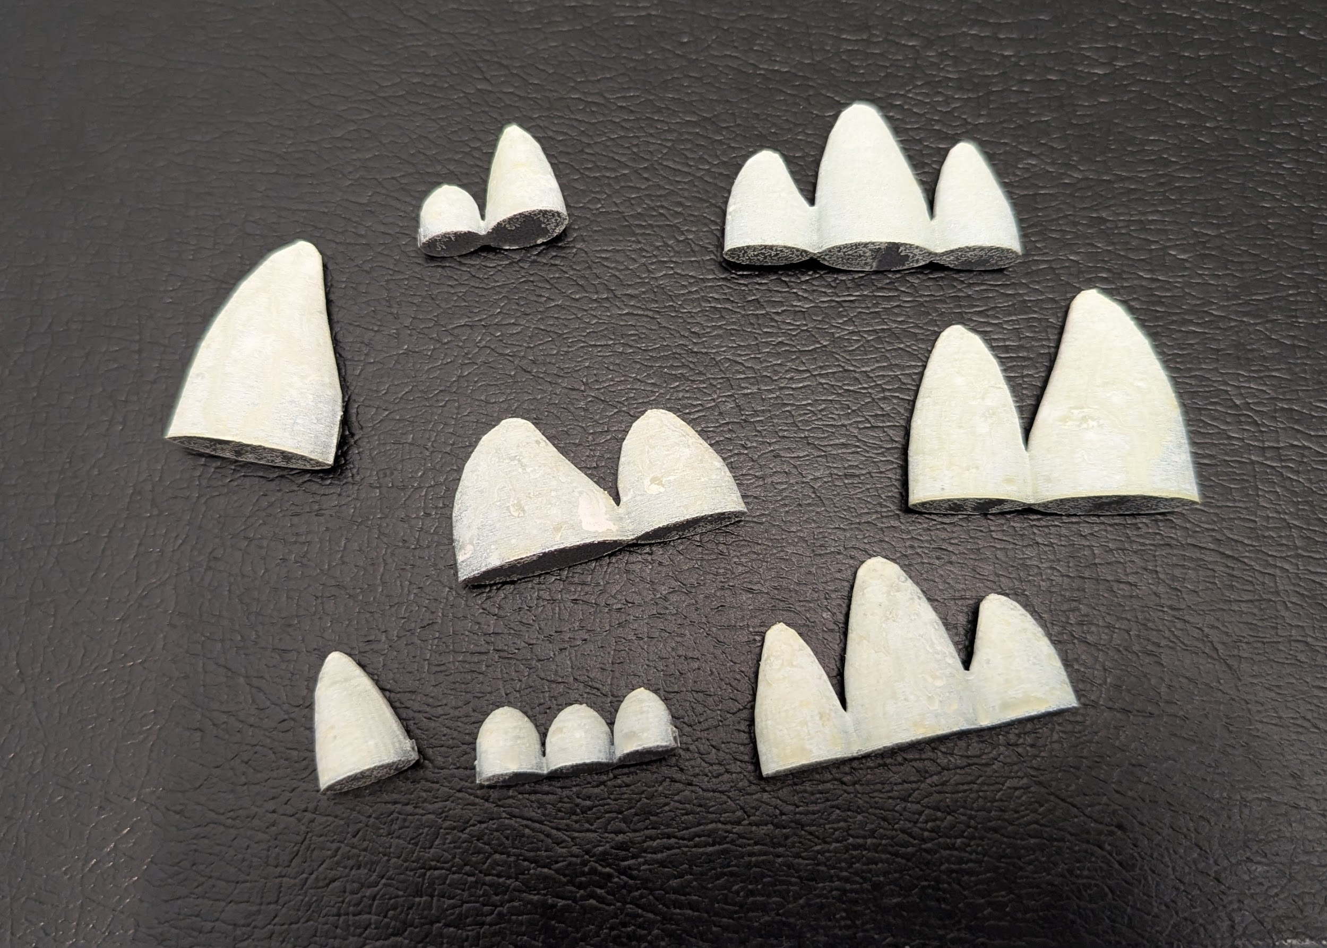
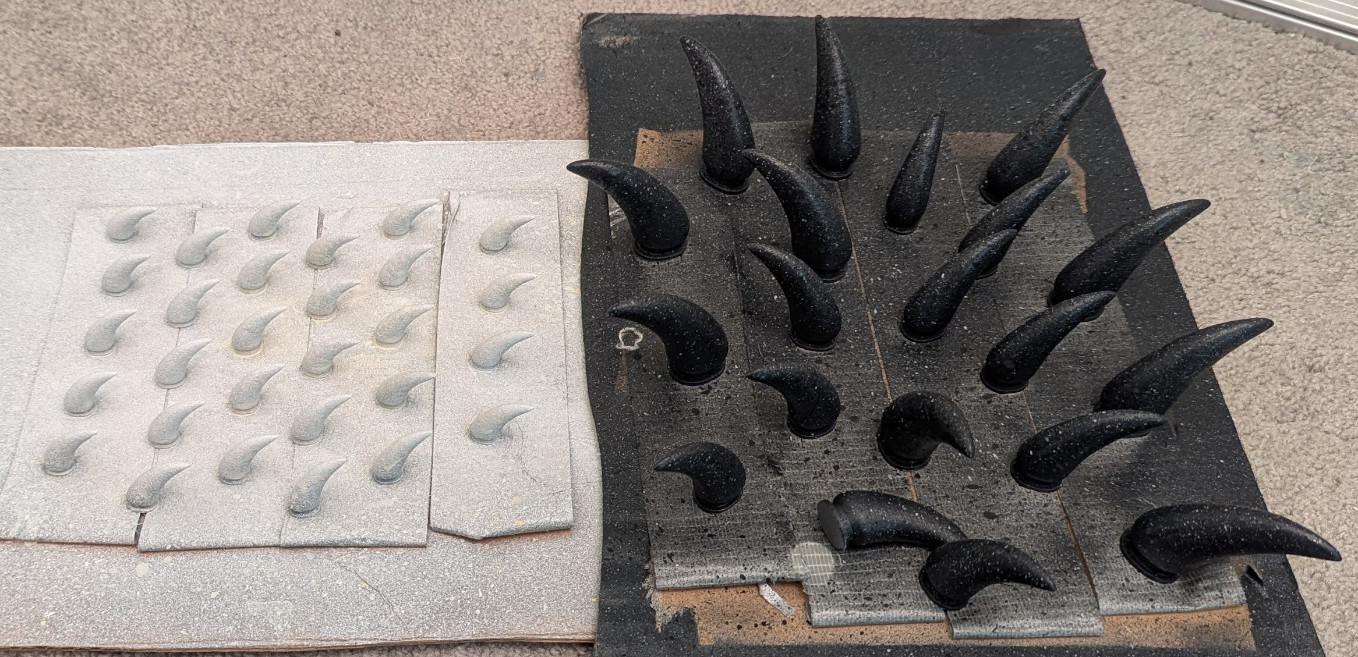
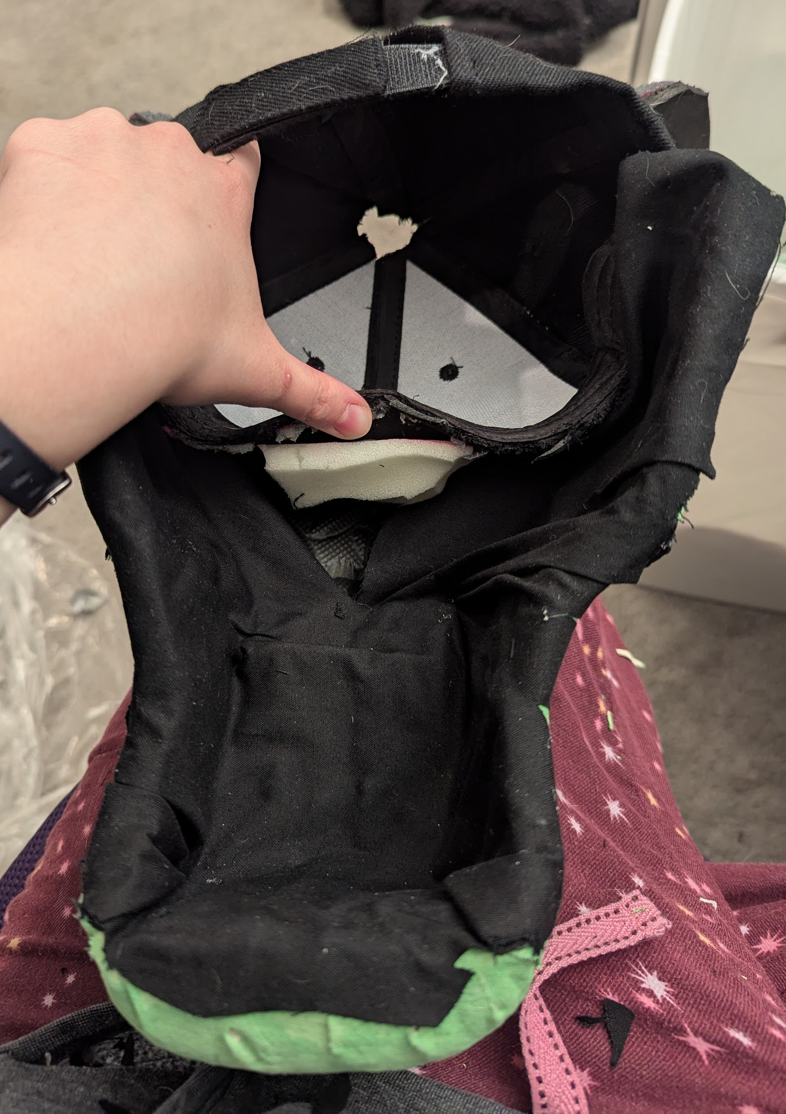
MISCELLANEOUS PROGRESS PHOTOS
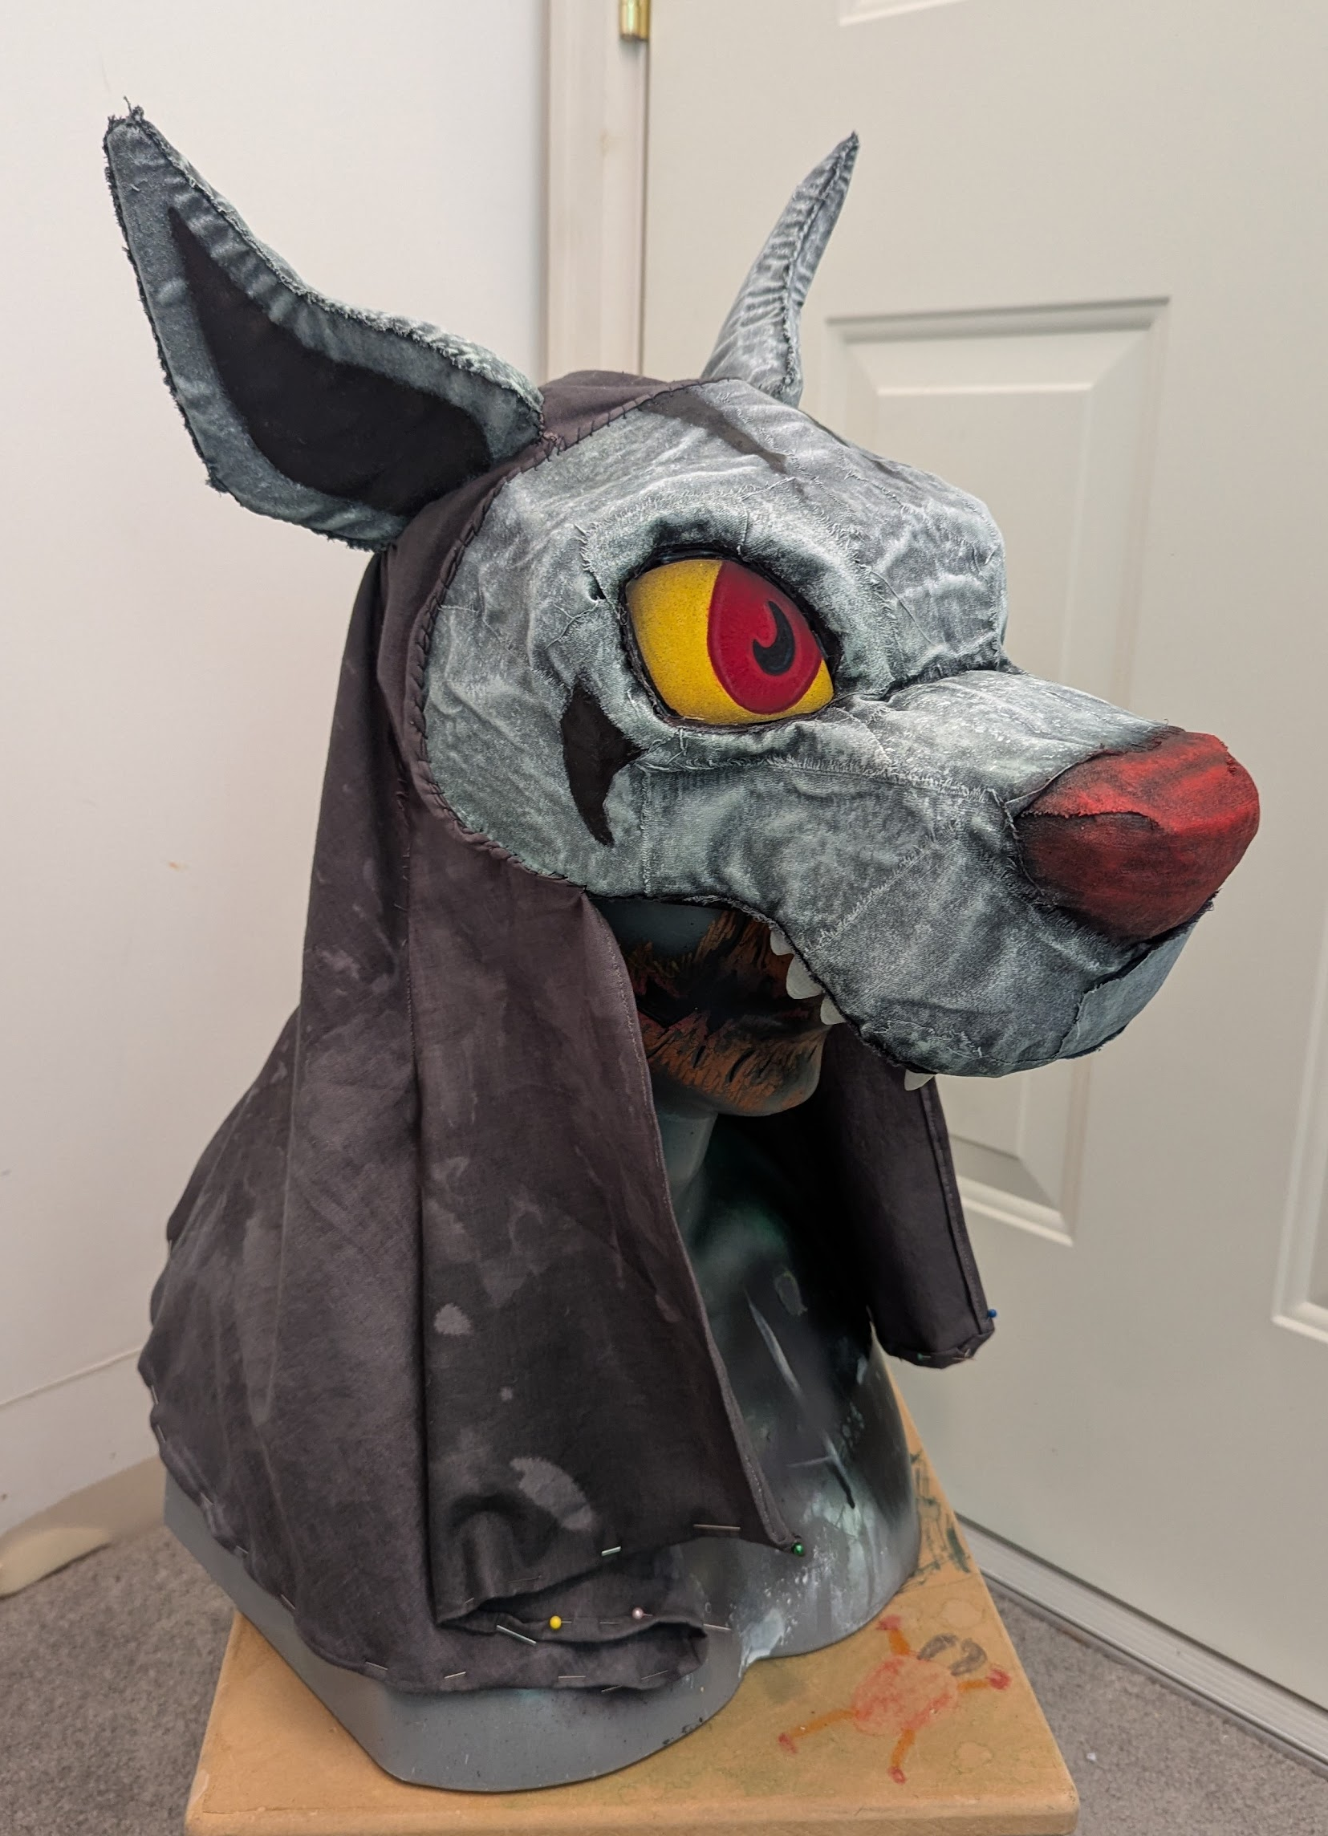
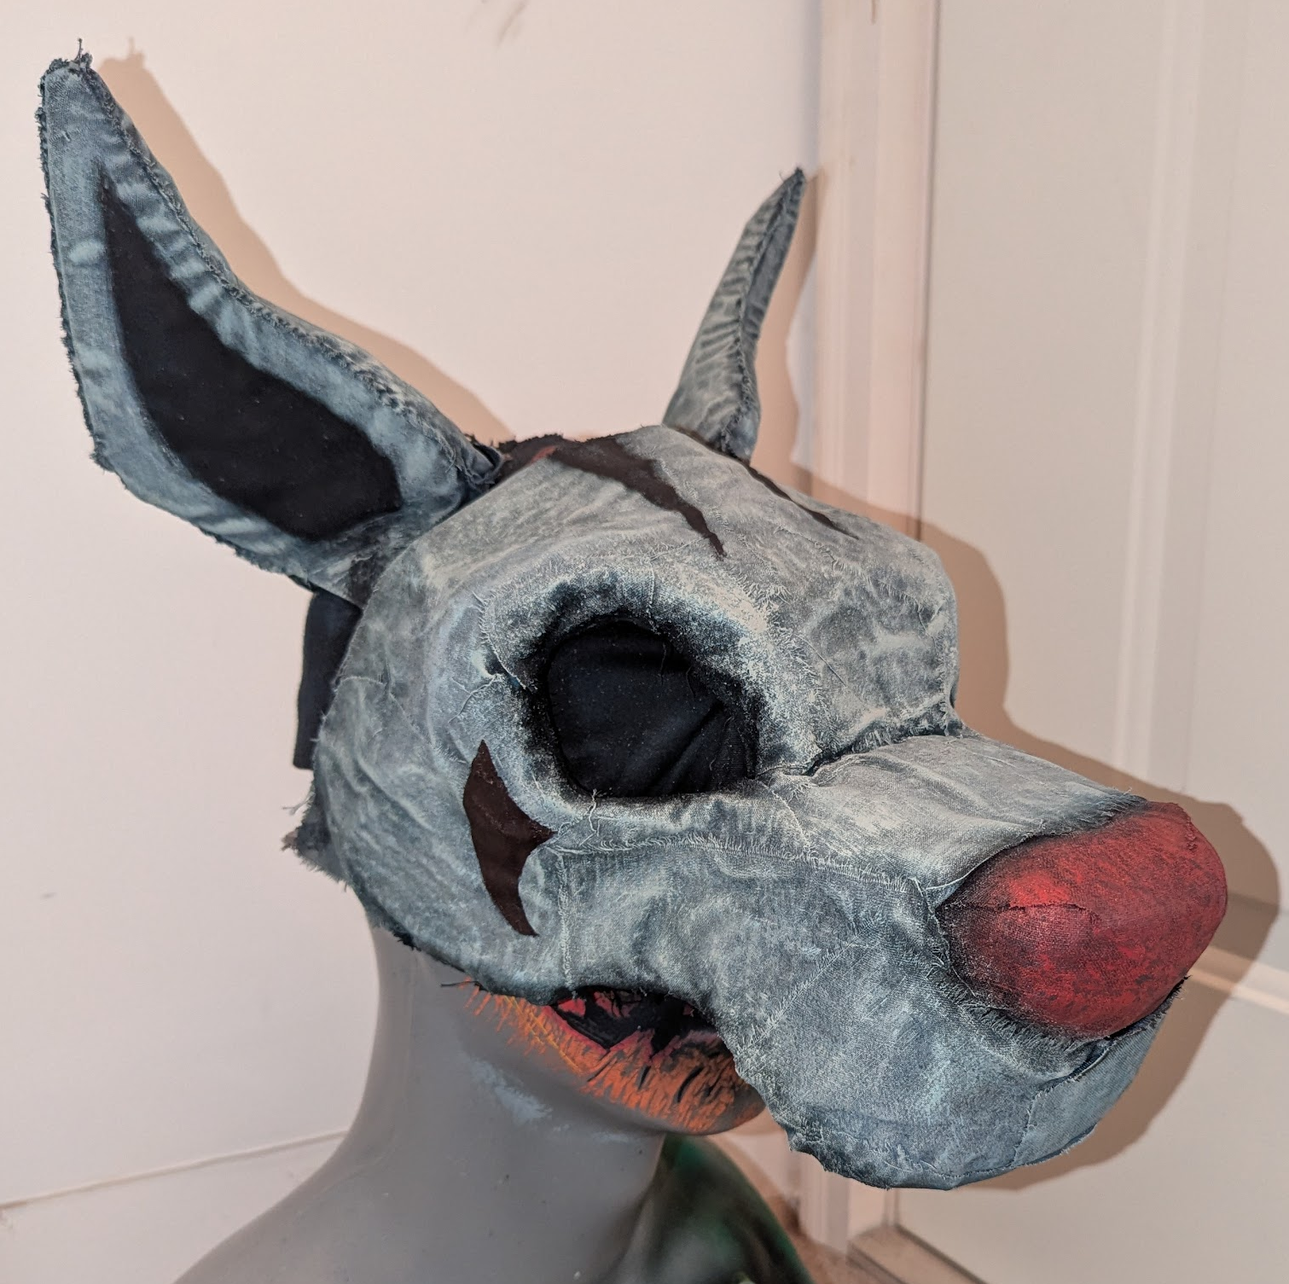
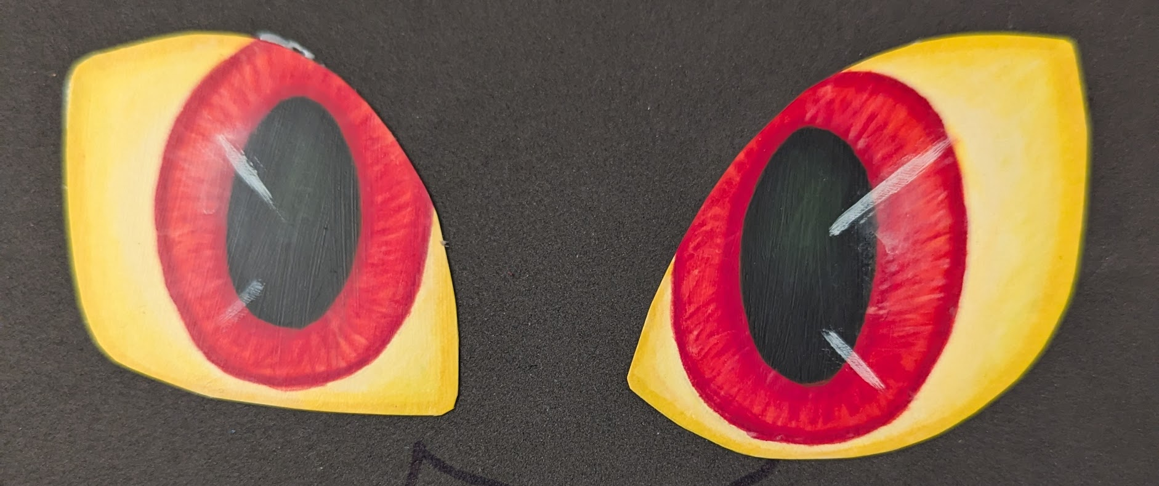
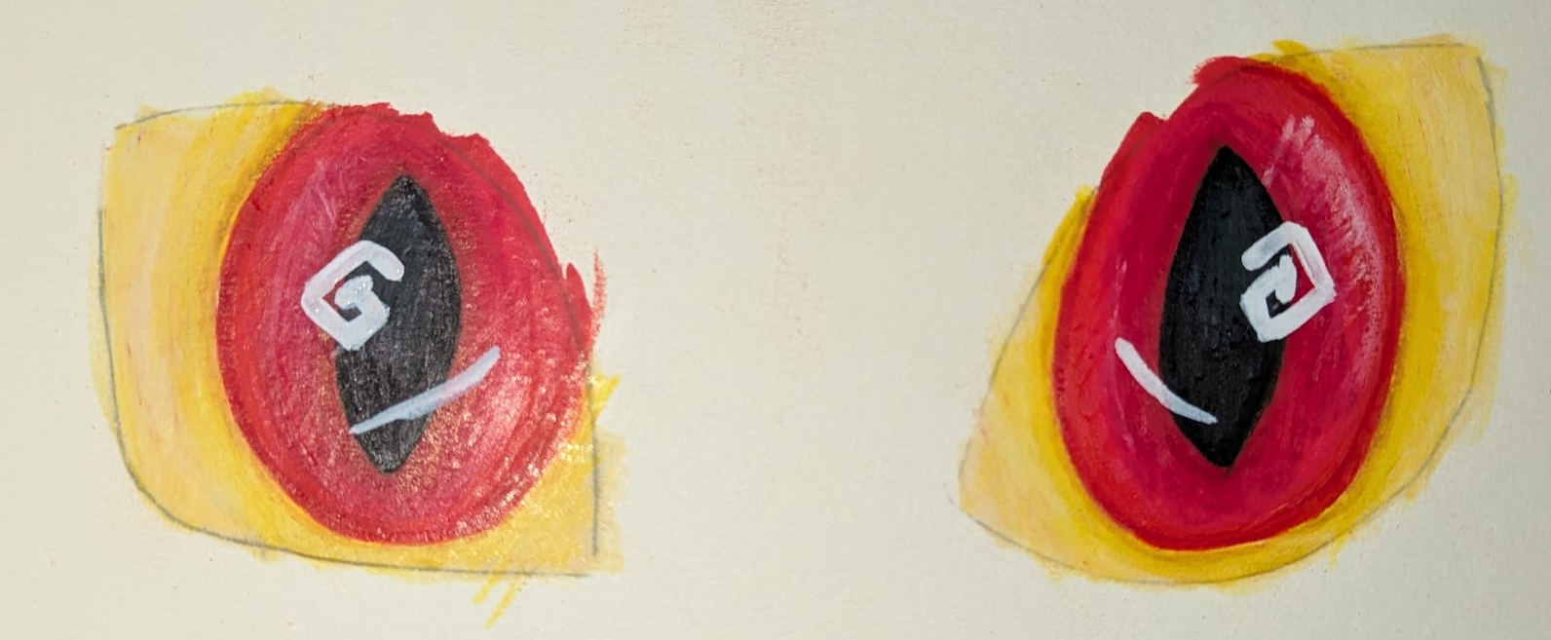
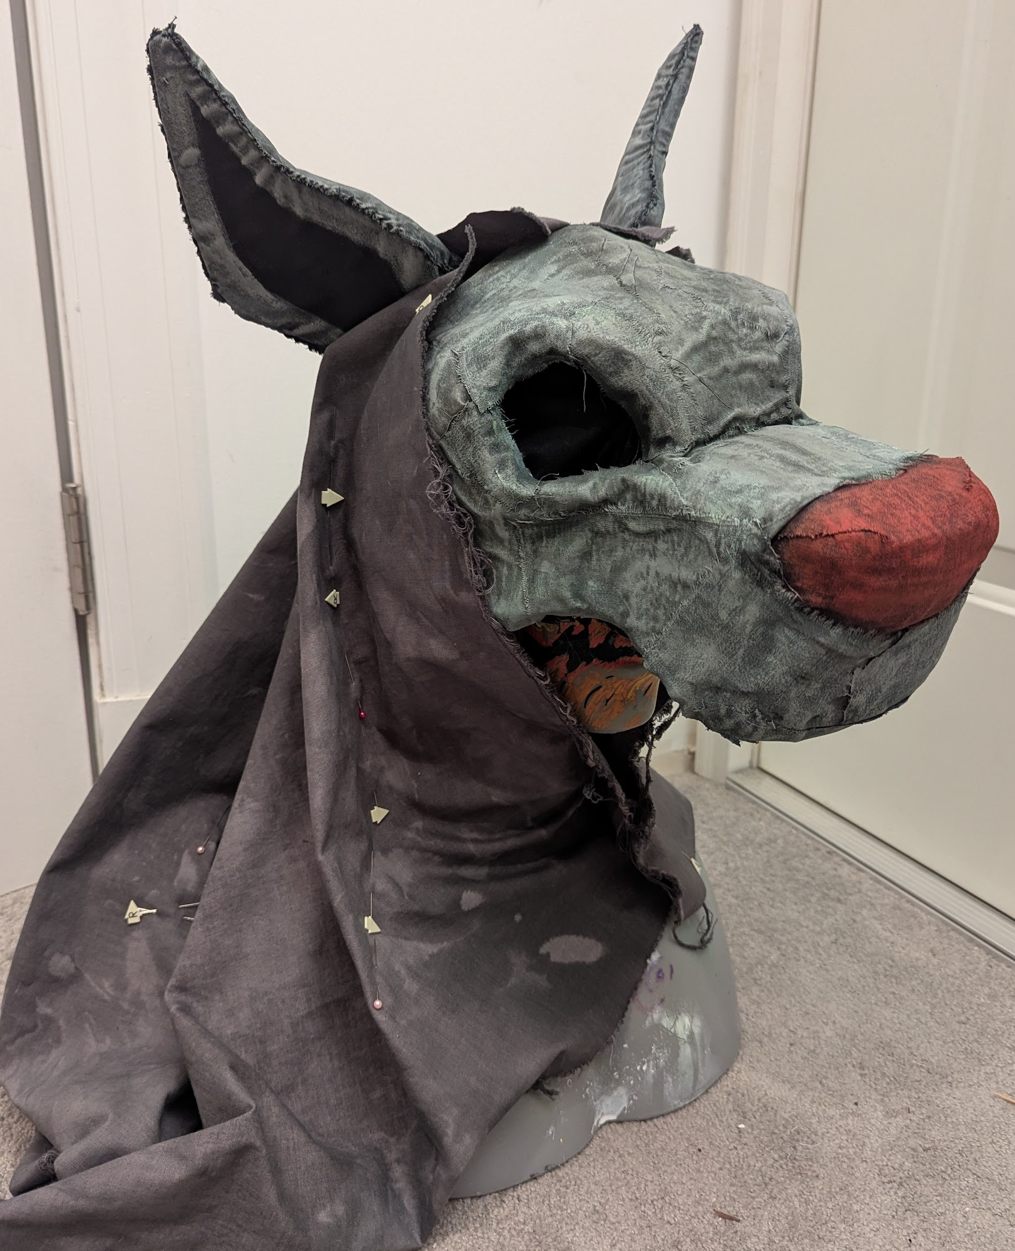
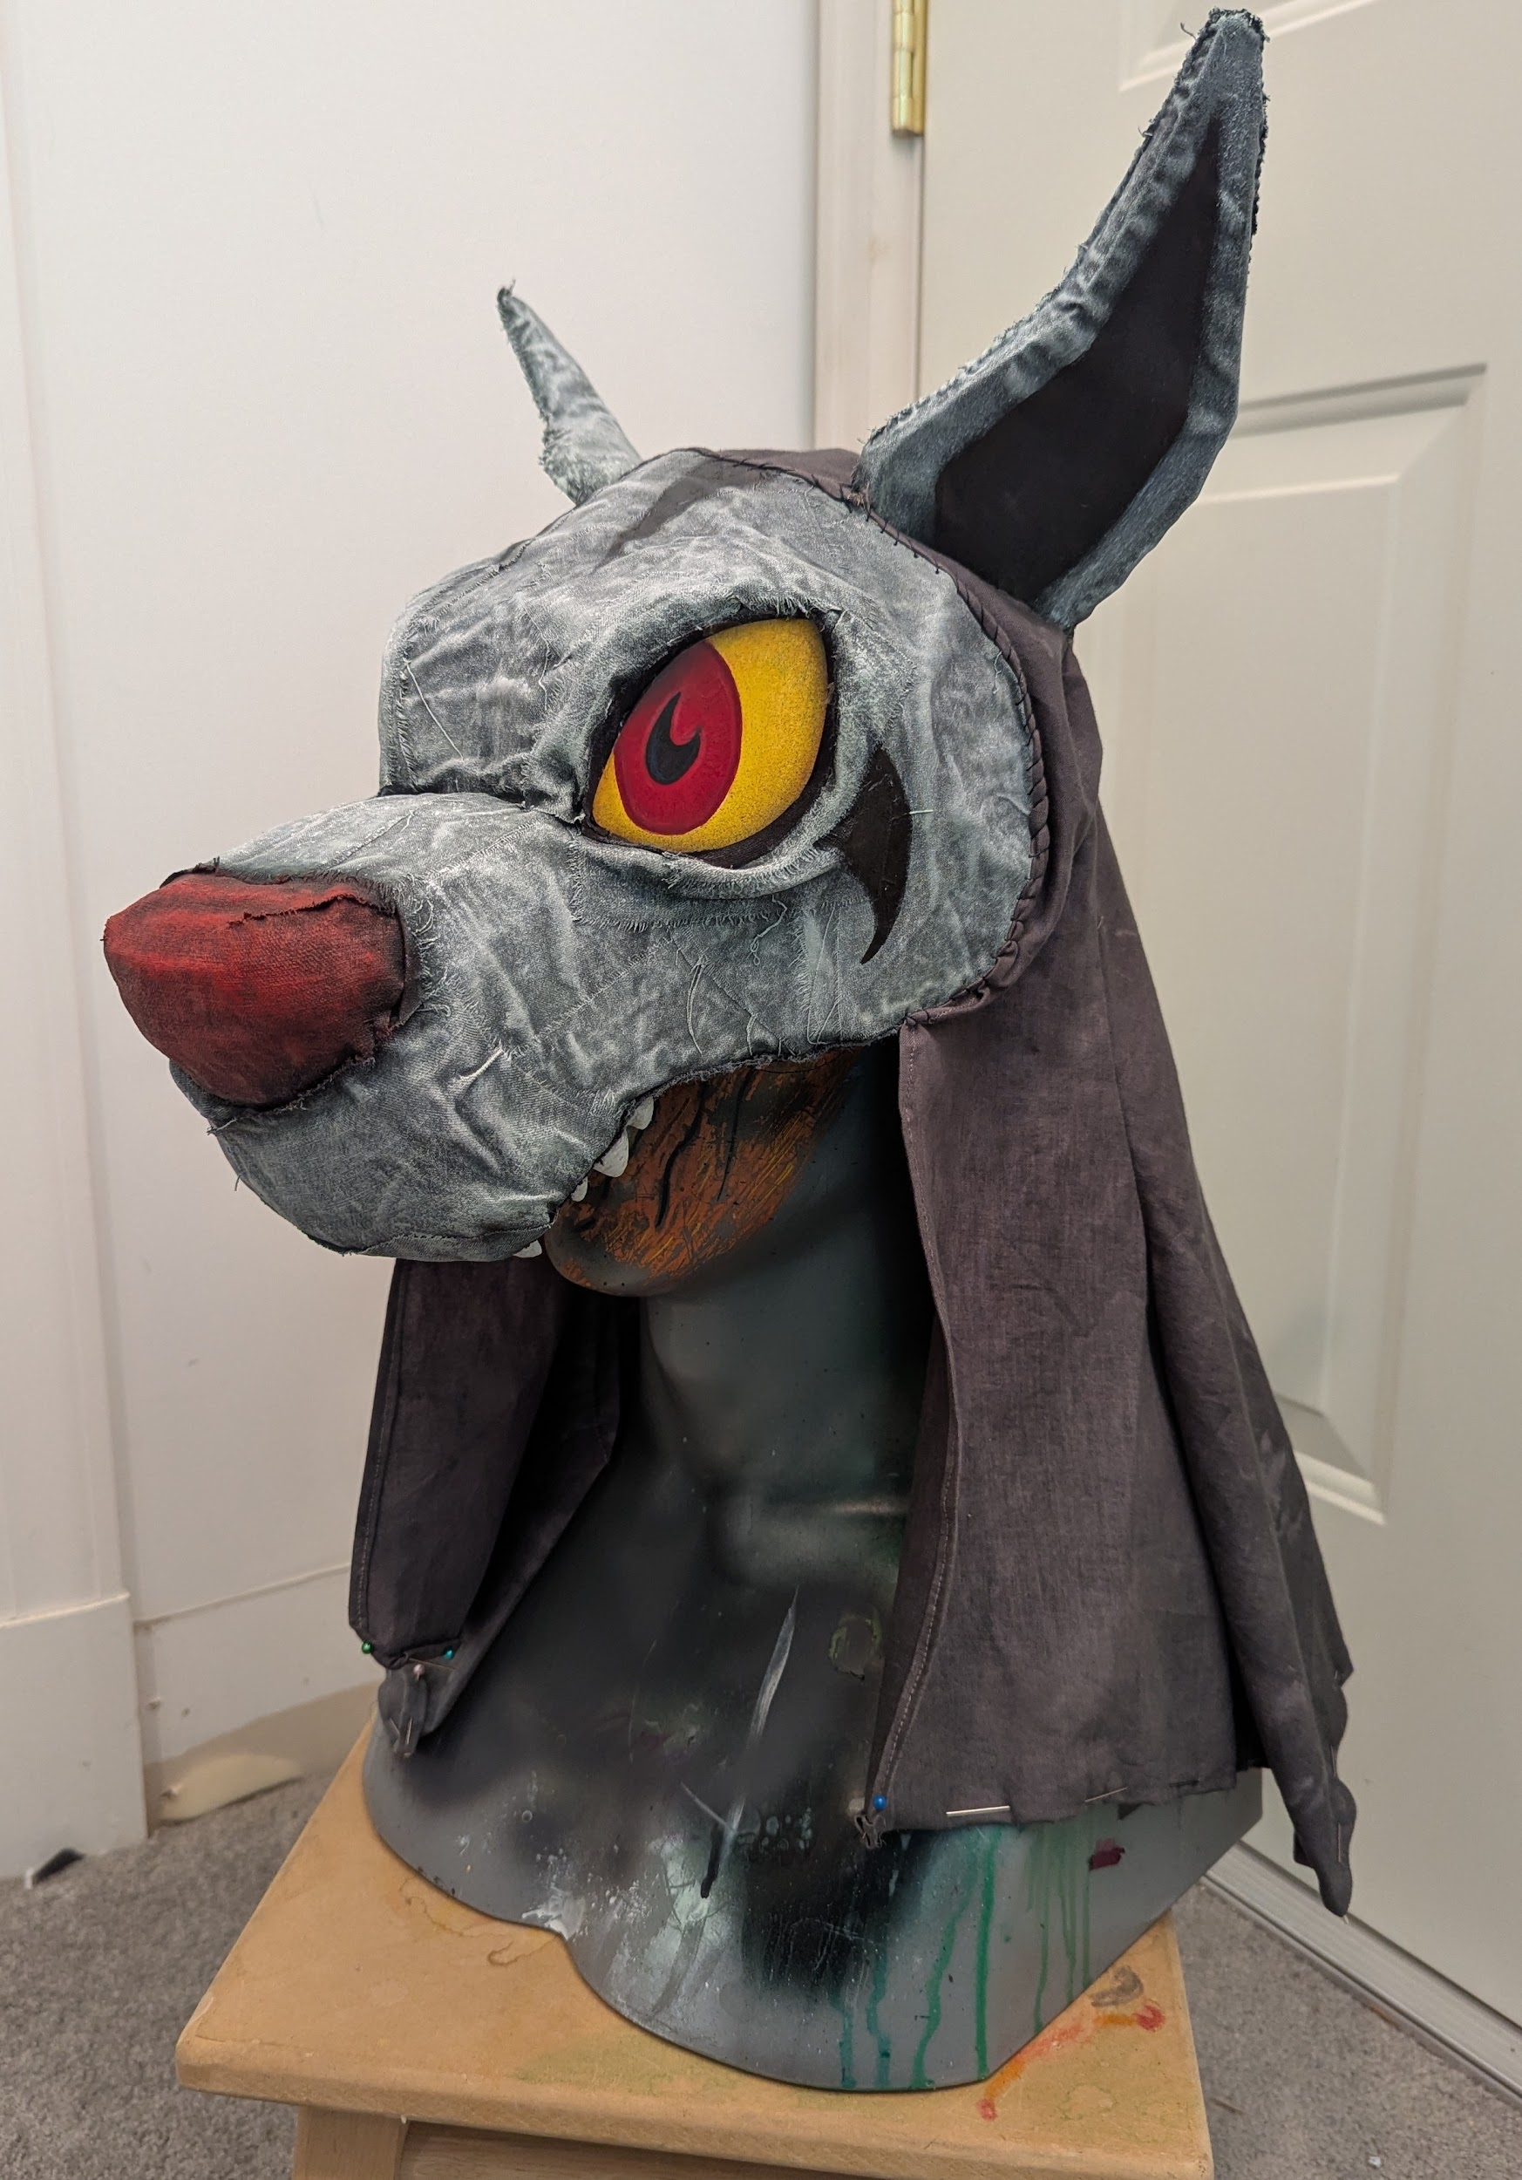
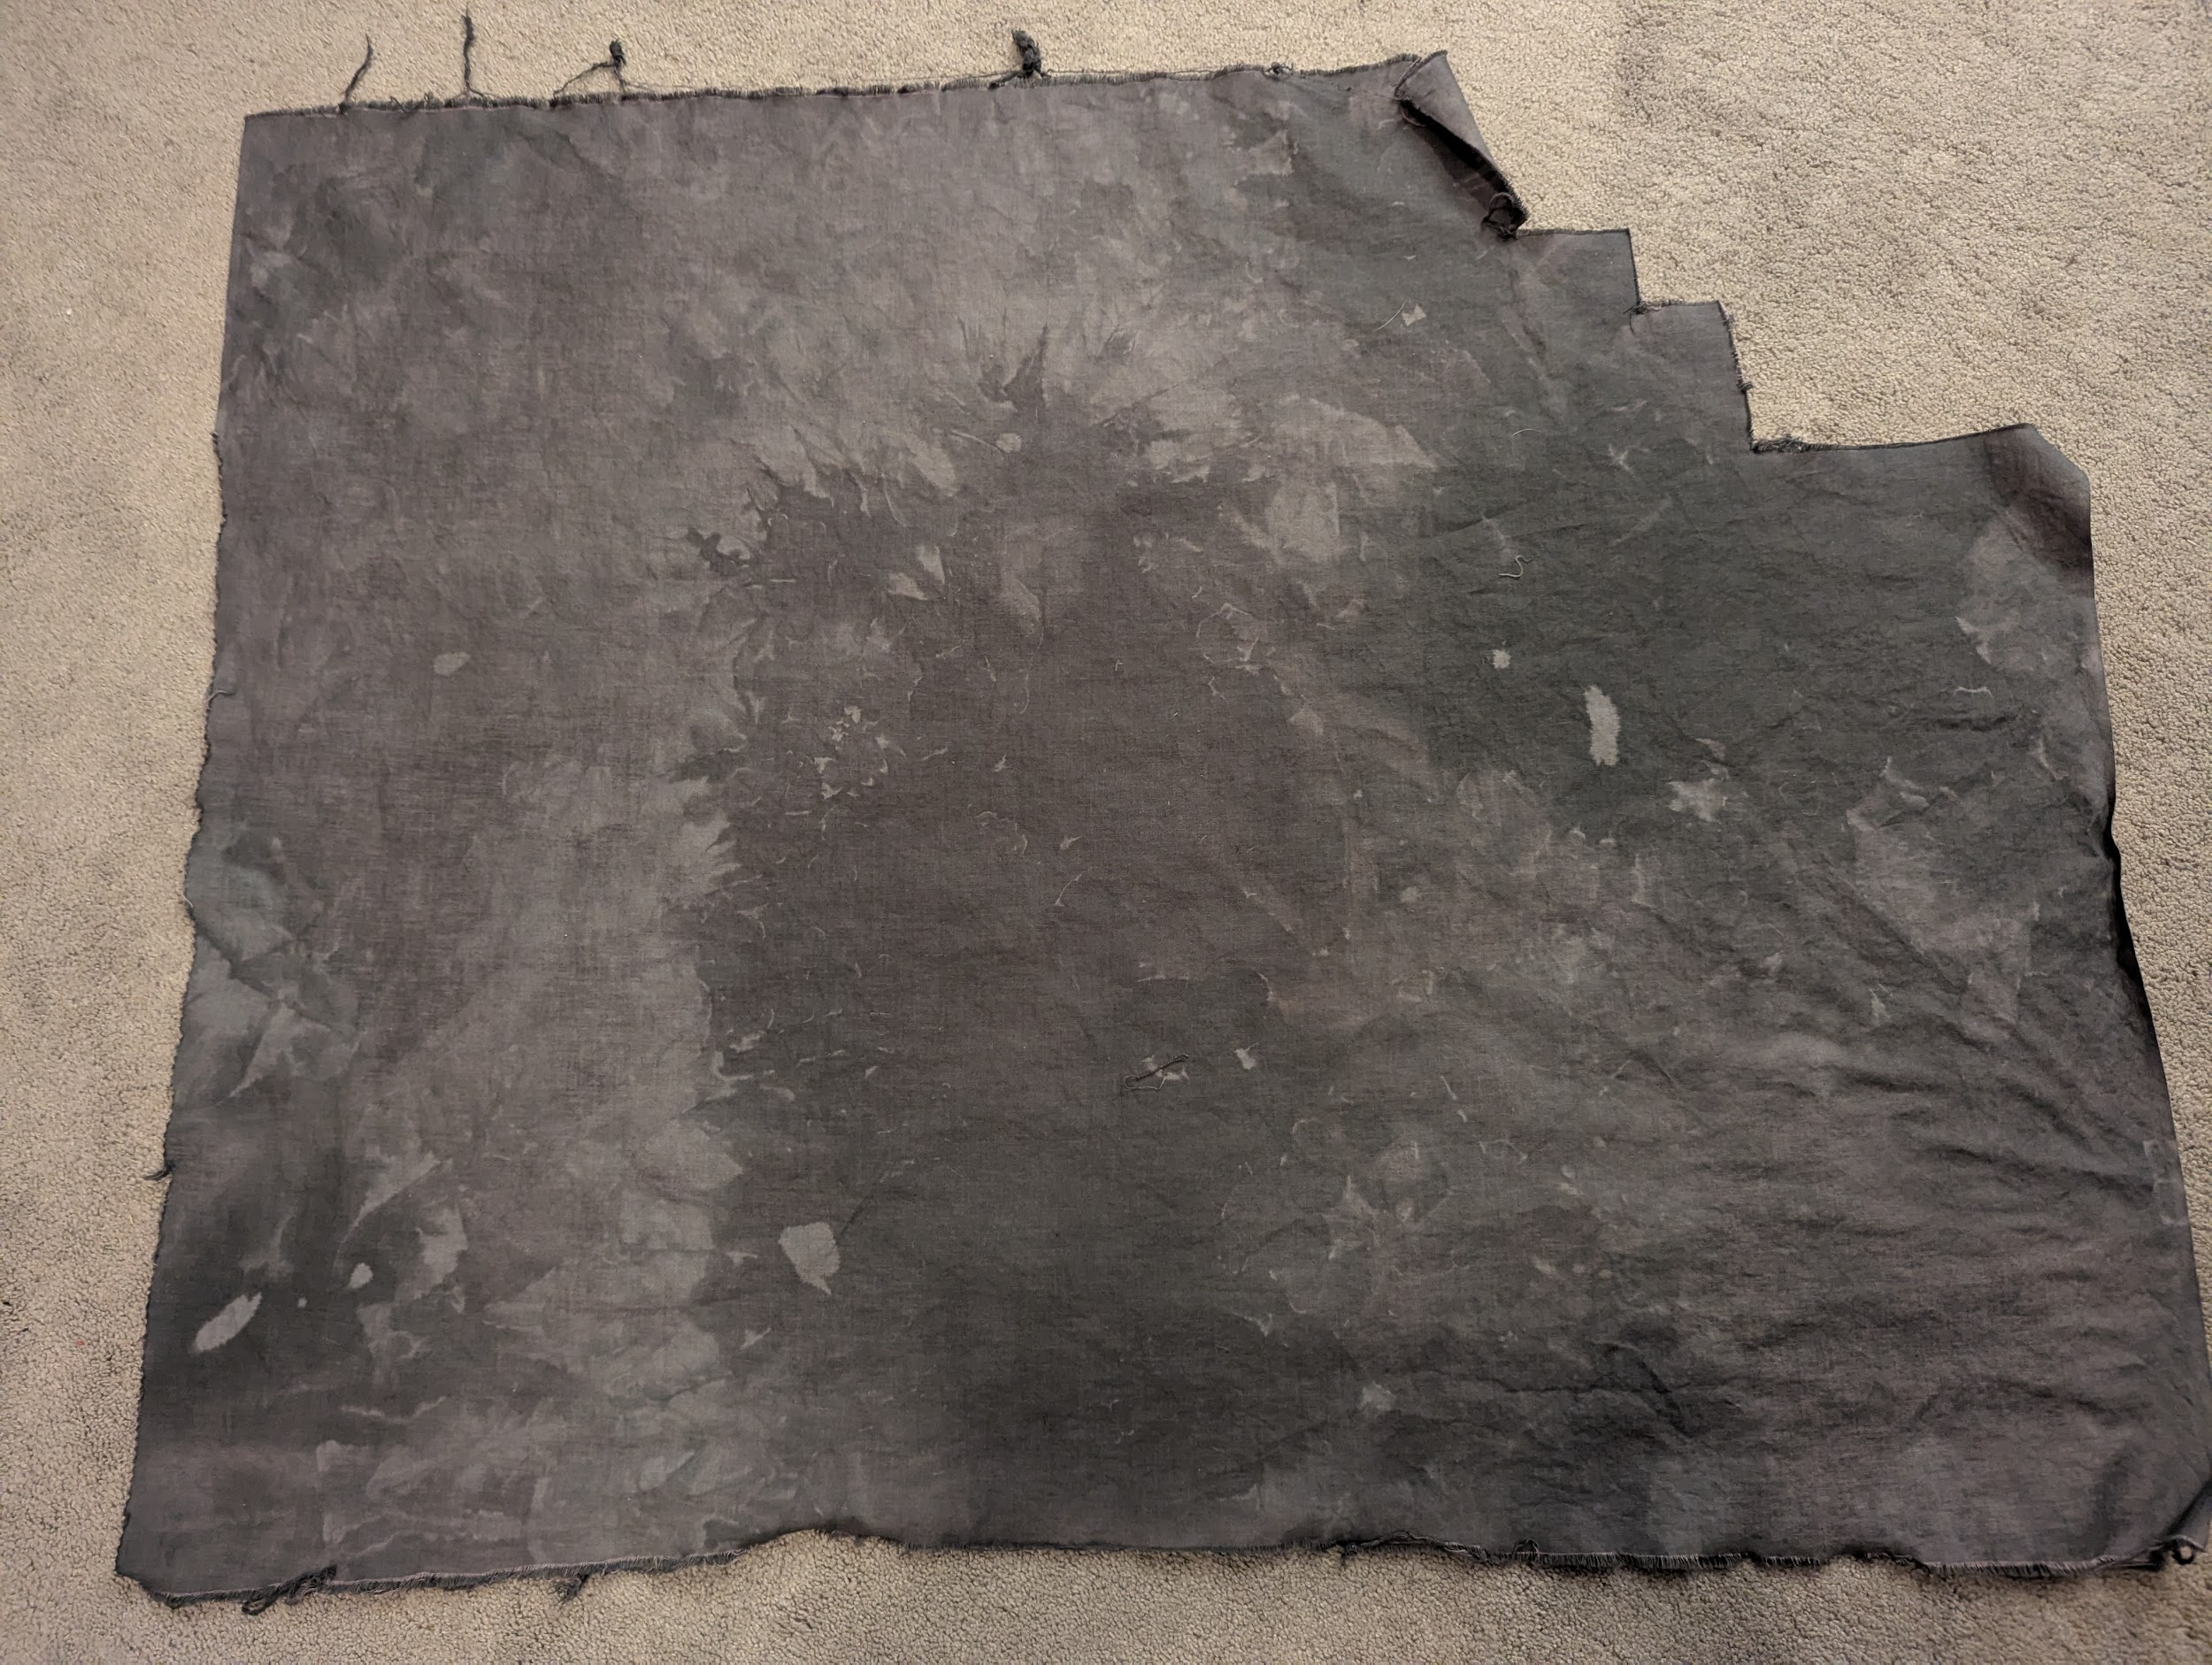
Works Cited
Amidei, Aly Renee. "Where'd I Put My Character? The Costume Character Body and Essential Costuming for the Ensemble Actor." Theatre Symposium, vol. 26, 2018, p. 49-57. Project MUSE, https://dx.doi.org/10.1353/tsy.2018.0003.
"Anime Los Angeles was CRAZY." YouTube, uploaded by Sarah Spaceman, 20 Feb. 2025, https://www.youtube.com/watch?v=Uc8fXp3pynA
"Behind the Scenes in The Lion King's Puppet Shop." YouTube, uploaded by Adam Savage's Tested, 19 Dec. 2016, https://www.youtube.com/watch?v=rvCgPRzOa3s
Brook, Peter. The Empty Space. New York :Atheneum, 1968.
Blumenthal, E. (1995). Julie Taymor: Playing With Fire. Harry N. Abrams, Inc.
DisneyOnBroadway [@disneyonbroadway]. "It's time to chow down!" TikTok, 10 May 2023, https://www.tiktok.com/@disneyonbroadway/video/7231660002090421546
Gcinalove [@gcinajobe]. "Hyena Costume Shenanigans: Ed and Shenzi's Funny Antics!" TikTok, 27 Mar. 2024, https://www.tiktok.com/@gcinajobe/video/7351063755402251552
"How to make a Build Book for a Cosplay Competition | Going through my Toph Buildbook & 7 good tips!" YouTube, uploaded by KirileeCosplay, 27 Oct. 2023, https://www.youtube.com/watch?v=C44UkxgUY30
Laver, James. Costume in the Theatre. 1965. First Dramabook Edition, Hill and Wang, 1967.
Mack, John. Masks : The Art of Expression. London, British Museum, 1996.
Salisbury, Mark. “How Different-Sized Shoes Helped Michael B Jordan Play Twins in ‘Sinners.’” Screen Daily, 15 Dec. 2025, www.screendaily.com/features/how-different-sized-shoes-helped-michael-b-jordan-play-twins-in-sinners/5211863.article.
Satinsky, E., & Nicole Green, D. (2016). Critical Studies in Men’s Fashion. Negotiating Identities in the Furry Fandom Through Costuming, 3(2).
"The Lion King on Broadway | Discover the Costumes | Disney Style." YouTube, uploaded by Disney Style, 1 Mar. 2012, https://www.youtube.com/watch?v=hYAph4qI4sg
Winge, T. (2019). Costuming Cosplay: Dressing the Imagination. Bloomsbury.

